GOVT. DEGREE(PG) COLLEGE BHADERWAH

**(NAAC Accredited ‘B’ Grade College)**

**Bhaderwah-182222 Jammu and Kashmir**

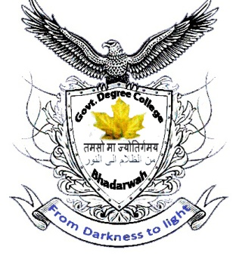

**Academic Calendar**

|  |  |  |
| --- | --- | --- |
|  | **Admission odd semesters** | **For odd semesters - July** |
|  | **Class work odd semesters** | **For odd semesters –August**  **For even semesters - February** |
|  | **College Timing** | **From 10.00am to 4.00pm** |
|  | **College Cultural Programme** | **On important dates** |
|  | **Picnics odd semesters** | **For odd semesters - April/May**  **For even semesters - October/November** |
|  | **Summer Vacations** | **15th of July to 24th of July.** |
|  | **College Sports Week** | **For odd semesters: 1st Sept. to 7th Sept.**  **For even semesters: 1st March to 7th March** |
|  | **Inter Class Quiz Competition** | **For odd semesters: 13th of September**  **For even semesters: 20th of March** |
|  | **Inter Class Seminars and Symposia** | **Every Saturday** |
|  | **Conduct of 1st Internal Assessment Test (Theory)** | **For odd semesters: October**  **For even semesters: April** |
|  | **Annual Day** | **Last week of Nov./Dec.** |
|  | **NSS/NCC/RRC Programmes /**  **Local Special Camp Workshop**  **S. Service within the Campus** | **Weekly/Monthly/Important Occasions** |
|  | **Research and Extension Activities** | **Weekly/Monthly** |
|  | **Winter Break** | **27th of December to 14th of February** |
|  | **Conduct of Practical Exam (External)** | **After the External Examinations** |
|  | **Semester end examinations** | **For odd semesters: 1st of December to 31st of December**  **For even semesters: 15th of June to 14th of July** |
|  | **University result** | **To be declared by the University of Jammu.** |