IQAC CONTRIBUTIONS 2018- 2019
S.No | Activities by NSS,NCC, RRC, CC, MD, PC, IQAC | Date | Report
01 |  |  | International Youth Day 14-08-2018  Prakarma Day 29-30 Sept,2018  Organised Entrepreneurship cum Boot Camp with JK EDI,Doda on 10-04-2018  organised One day Programme on career and Counseling 29-08-2018  Organized Constitional Day 2018 on 26 November 2018  Organised International Women Day 2018  Organised Rashtriya Ekta Diwas 2018 with Pledge and run for unity  Organised NSS Day 2018  IQAC initiated NCC/NSS Swachta Pakhwara 1-15 August 2018  IQAC initiated Swatch Bharat Summer Internship 2018  Prepared & submitted AQARs, IIQA and SSR for NAAC Cycle-2 during 2018  Organised NAAC Peer Team Visit on 2nd and 3rd March 2019 and Organized Alumni Meet, Cultural Evening during exit meet  Organized Workshop on NAAC Awareness on 29-03-2018  OrgaisedOne Day National Seminar organized by GDC Bhaderwah on "Spirituality, Education and Life" on 18th June, 2018  Organized Motivational Talk on International Day on Women's Day with Col.D.D.Pandey as Chief Guest  Organized Seminar on Financial Frauds and Protection on 25-04-2019 in RBI Ombudsman  Organized Seminar on Theater and Cinema 08-05-2019 with Padma Shree Balwant Thakur as a Resource person
02 | Gender Initiatives | Gender Initiatives | 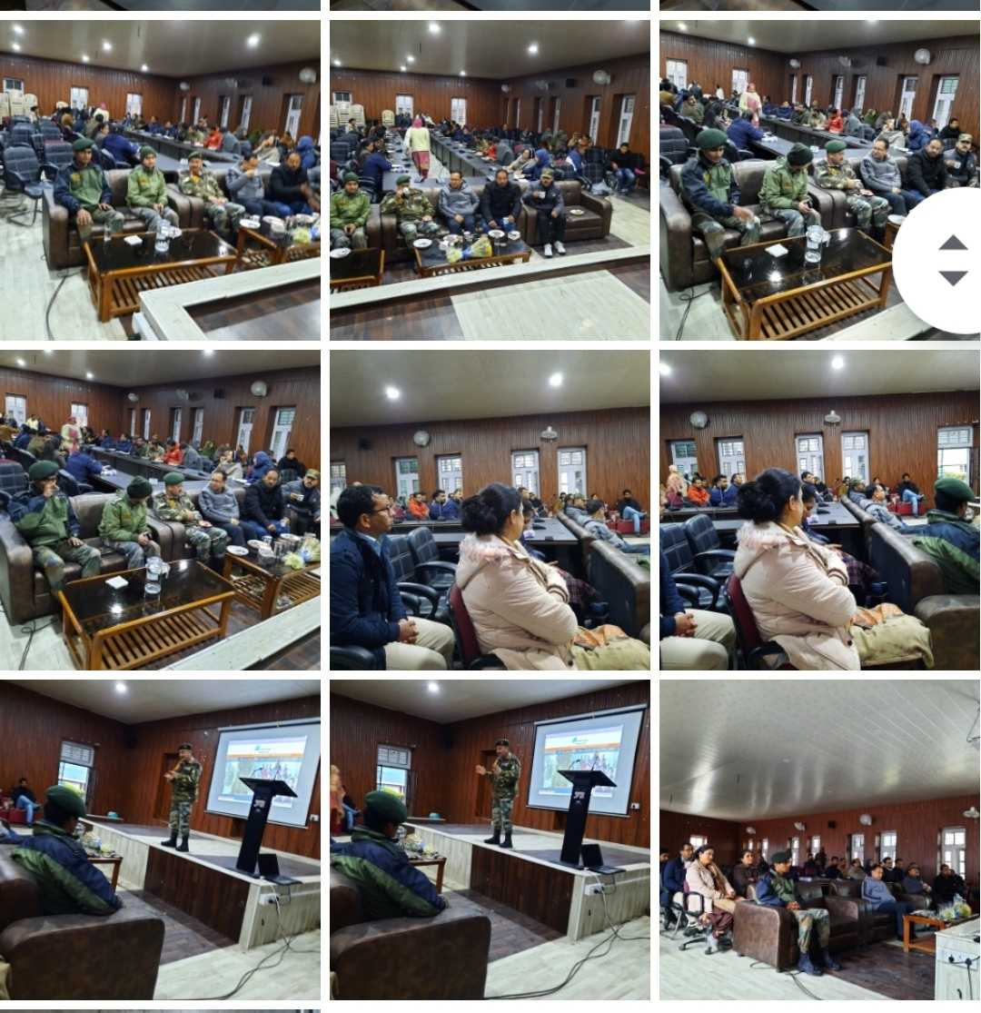
03 | 21 June 2019 |  | Local Folk Dance  https://youtu.be/KZ3zbk_pXc0
 | 31oct 2018 basant rath lecture |  | IGP SH BASANT RATH Interacts with the Staff and the Students:  https://youtu.be/1-96qEMb0_U
 | Cultural evening | 19 March 2019 | Diku-Traditional Dance of Bhaderwah  https://youtu.be/BKFaFtdY7PQ
04 | 21 2019June |  | International Yoga Day 2019  https://youtu.be/uRUwZSJ4TgU  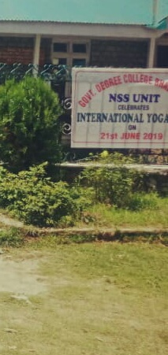
05 | 9 sept 2018 |  | Geographical Field Trip to Khellani Top  https://youtu.be/1TsxiPexLy8
07 |  |  | https://youtu.be/AkEMetmHaBs
08 |  |  | https://youtu.be/ycFhtLY76a0  Punctuality week
09 | 5 april 2019 | Final year Farewell | https://youtu.be/TjP_w7aM93o
09 |  | Kargi Vijay Diwas2021 | https://youtu.be/KJ4utsiUYsU
10 | Mushiera | 21 sept 2018 | https://youtu.be/vhoMqVdUaao
11 |  | 21-22 | https://youtu.be/r5fLWN78_GU  sadbhavana 21
12 | Two Weeks FDP | 1-15 June ,2020 | Press Release  Two Weeks FDP on E-Teaching and Learning Initiated on June 1st Culminates today at GDC Bhaderwah Internal Quality Assurance Cell (IQAC) ,Government Degree College ,Bhaderwah ,under the quality initiatives of Higher Education Department ,UT of J and K led by worthy Commissioner Secretary Sh Talat Parvez Rohela organized, Two Weeks Faculty Development Programme on the E-Teaching and Learning from 1st June to 15th June 2020 .The course structure of the training programme for the faculty was conceptualized , developed and designed by Professor Surinder Singh Parihar ,HoD Economics and Convener IQAC and organizer of the FDP. The course schedule was divided into three Modules as Modules 1 covered E-Teaching and Learning (ETL)Model and the Flipped Class Room, a flexible ,24/7 and anywhere anytime class practicability, Module 2 focused on Google Class Room Management, Google Forms and E-Certification ,Cisco Webex Meet, Google Meet and Zoom Meet as how to manage the class room and handle these video interactive platforms and Module 3 emphasized on Presentation Tube, Canvas platform and e-resources .Each Module was followed by discussions ,problem solving and completing and uploading assignment or projects at the end of the Module. The course structure was based on Flipped Class room and Web Quest e-teaching learning strategy where the participants were given the e-contents through video links prepared for the same as pre-class activity and the participants were expected to go through the links and enter the digital class room for discussions, problem solving and bringing innovative ideas relating to the Modules to expand and share the knowledge in presence of the teacher as facilitator. After class the participants assigned projects to be submitted within the specified dates .The assessment was based on Rubric a quality assessment tool to acquaint the participants with this tool too. Total 132 faculty members from different Colleges of Jammu and Kashmir showed their interest to join the training programme and participate in hands on practice in the FDP but due network problems and slow speed it became little bit difficult for all to go digitally on daily basis and accomplish all tasks .But yes 60 faculty members got fully associated and completed all their tasks and assignments and majority of them ready to act as the resource persons now for online courses and e-contents. At the end of the course Feedback was collected from the participants and going through the feedback it appears that the participants really enjoyed the training prorgramme and new things they practiced with in all three modules with the other peers on the platform. According to the participants the course was motivating, interesting and relevant in the current scenario. The course was launched through the Canvas Platform. All the participants who completed the course shall be issued e-certificates within a week’s time and the rest participants shall be given opportunity to accomplish their all pending tasks so that they can also get e-certificates .Principal of the college, Dr. Kuldeep Kumar Sharma congratulated the organizers for organizing such an important training event which is a part of NAAC quality initiatives for the Higher Education Institutes and thanked the participants for the successful completion of the course. Prof. Arjun Kotwal, HOD Computer Science acted as a Technical Co-coordinator and Prof. Vijay Kumar as Mentor for the course.  Patron  Dr. K. K. Sharma  Principal  Organizer  Prof. Surinder Singh Parihar  Technical Coordinator  Prof. Arjun Kotwal
 | 7apr 2019 | Farewell to PG | https://youtu.be/yaXE8Jyp8sQ
 | 14 December |  | https://youtu.be/veTAKOW4Qgw  Punjabi Dance by GDC Bhaderwah Students

Under Best Practices v Adopted:Kotli and Narnu villages of Bhaderwah

