IQAC CONTRIBUTIONS 2019-20
S.No | Activities by NSS,NCC, RRC, CC, MD, PC, IQAC | Date | Report
 | 10 July 2019 |  | 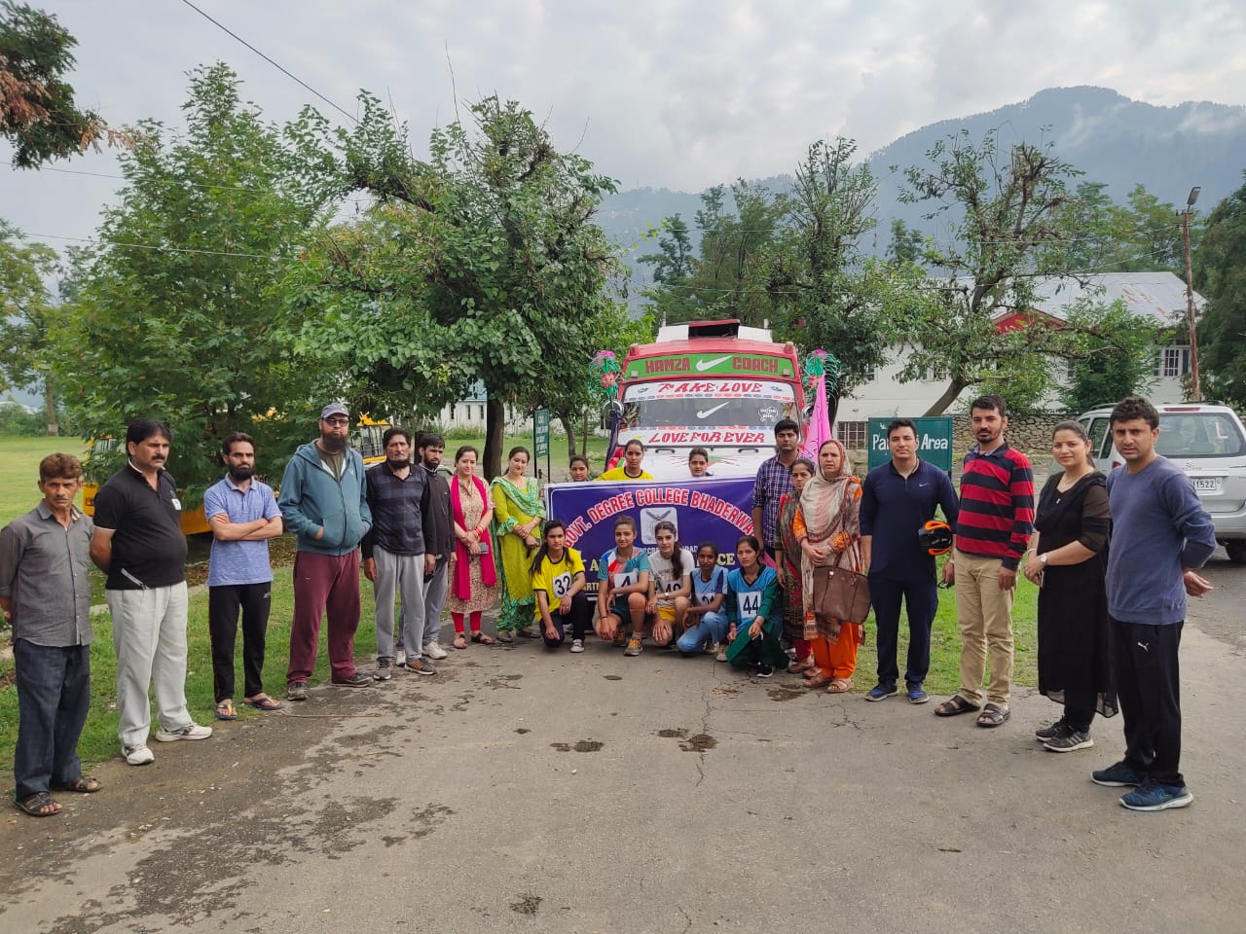
01 |  |  | 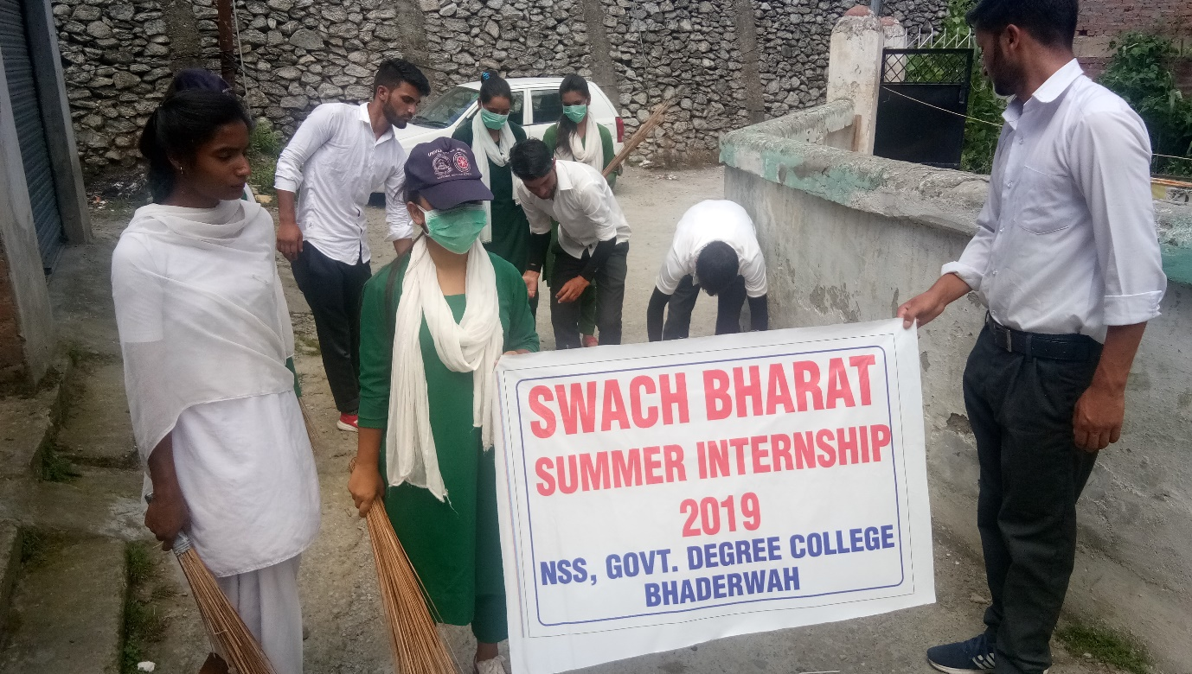  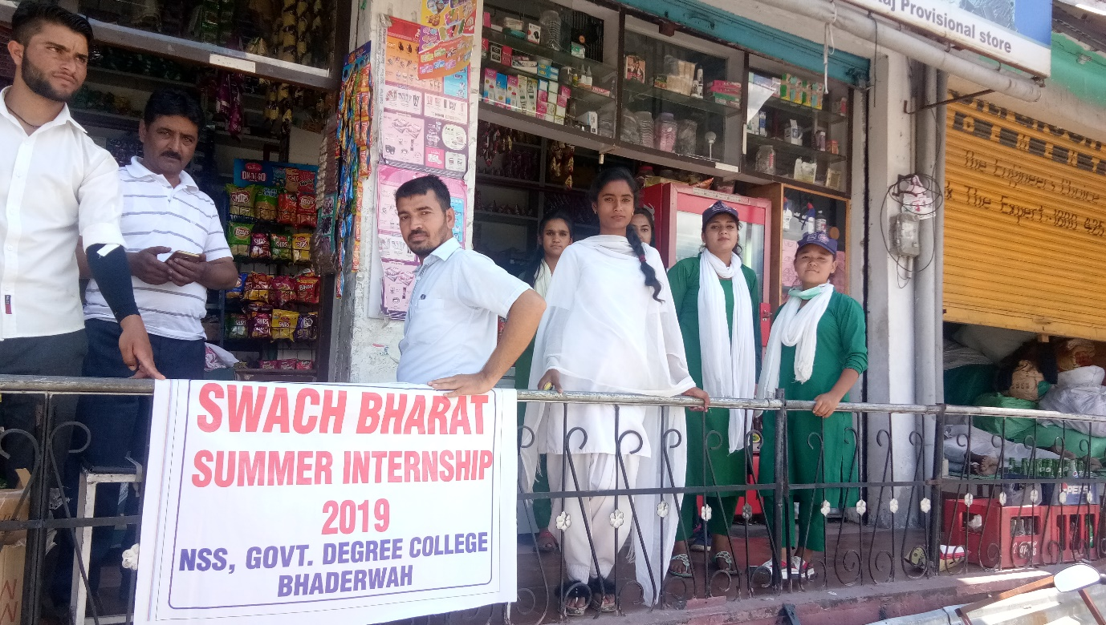  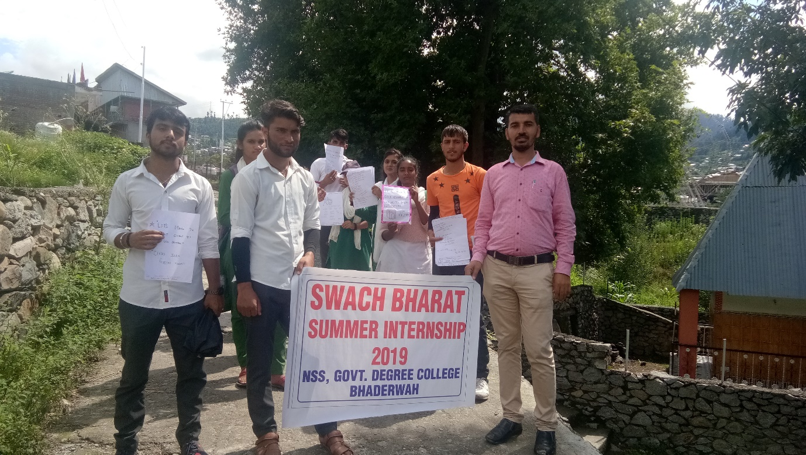 NSS UNIT GDC BHADERWAH CONCLUDES SBSI 2019  NSS Unit of GDC under the supervision and guidance of Programme Officer Prof. S.S.Parihar adopted Kotli Village Bhaderwah for SBSI 2019 with 50hrs time spending in different solid-liquid waste management activities between 23 July 2019 to 31st July 2019.In a week long programme w.e.f 23-07-2019 where in 15 to 20 volunteers took active participation in the cleanliness drives,segregation of solid and liquid waste,collection of solid waste,face to meetings and interactions with prominent citizens of the village ,Head Mistress Primary School Kotli,Sarpanch Kotli ,door to to door compaign and distribution of posters with beautiful slogans on swachta,clean and green India plantation drives ,waste disposal and management etc.The locals were made aware about the solid-liquid waste management and the to keep the dust bins for the collection of the waste . The villagers appreciated the students activities and ensured the to sustain such efforts to keep the village swacch.Interview with locals,old aged,younsters,experts and Sarchpanch were recorded relating the Internship programme.On daily basis the participants were served refreshment and they oerformed with happiness and satisfaction during the activity period.Earliar the NSS team was flagged off from the college by the Principal of the college,Prof. Davinder Kumar and other faculty members for the summer internship on 23rd July .  Organized Teaching of Gandhiji Teachings Week 23-30Aug,2019
NSS,NCC in Collobaration with JK Bank Financial Services Limited organized an awareness programme at GDC Bhaderwah about their recently launched wealth products.

A visiting team of experts from JK Bank Financial Services Limited (100% subsidiary of J&K Bank) organized an awareness programme at GDC Bhaderwah about their recently launched wealth products on 20-07-2019. A large number of employees of the college both teaching and non-teaching participated in the programme. The financial products introduced by the experts included demat, equity broking, equity derivative trading etc. Ms Reeti Soni (Relationship Manager Residency Road Jammu and Udhampur) shared her thoughts on equity derivative trading and delivered a detailed lecture on investment in equity market and risk management. She explained through a power point presentation the nitty-gritty of procedure to be followed in making investment in equity market. Mr. Munish Kumar Padha (Relationship Executive Bhaderwah Branch) spoke about investment in mutual funds. Mr. Abhinav Gupta (Relationship Executive Doda Branch) summarized the proceedings of the programme at the end and also expressed his satisfaction at the feedback and successful conclusion of the said event. It is pertinent to mention here that JK Bank Financial Service Limited out reach programme to the college was first of its kind. It was appreciated by one and all present in the programme.

Principal
Govt. Degree College
Bhaderwah

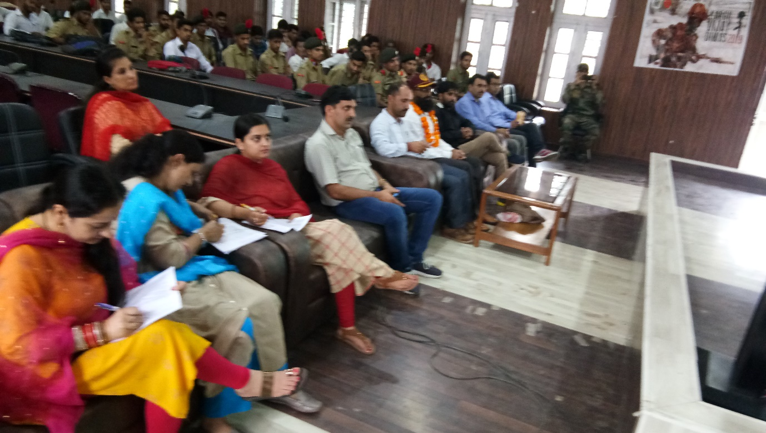NSS ,NCC SD and SW units of GDC Bhaderwah Celebrated Kargil Vijay Diwas
Kargil Vijay Diwas was celebrated by NSS, NCC SD and SW unit of GDC Bhaderwah. More than 120 cadets took part in the programme. Prof. Devinder Kumar Principal of the college was the chief guest and Ex Hawaldar Ghulam Qadir of 12 JKLI was special guest and he resource person. A grand and colorful Programme was presented by the cadets of NCC and a tribute was given to the Martyrs of Kargil war. Speaking on the occasion Prof. Prithvi Raj ANO/CTO SD, elaborated the importance of this day and emphasized over the celebration of such important days. Different programmes like skit, dance, singing and drama were performed by NCC Cadets. Prof. Devinder Kumar Principal of the college laid stress on celebrating such programmes to honor the war heroes. An extensive talk was made by the special guest Ex Hawaldaar Ghulam Qadir of 12 JKLI who explained the real situation faced during the war and how Operation Vijay was made successful. It is pertinent to mention here the this brave soldier lost his left eye in the said Operation Vijay. The programme was compared by cadet Syka Banoo, welcome address was given by senior cadet Satkarni Katal and vote of thanks was presented by senior cadet sandeep singh. The technical support was provided by Prof. Mohd Taqi HOD Geography. The teaching staff who were also present on the occasion were Prof. Sanjay Katal, Prof. Surinder Singh, Prof. Pinky Kotwal, Prof. Deepa Kak, Prof. Jai Mala Thakur, Prof. Ankush Kumar, Prof Deep Chand Prof. Arjun Kotwal, Prof Manjit,Prof. Archana Manhas, Prof. Nafeesa Zargar, Prof. Anita, Prof. Ravinder Kumar, S.O of the college Madam Rukhsana Banoo and Hawaldaar Darshan Lal from 2nd JK (I) Coy NCC Unit Bhaderwah. A refreshment was also served to the cadets.

Swachh Bharat Pakawara of 15 days got kick stared at GDC Bhaderwah.
A one day seminar was organized as a part of 15 days Swachh Bharat Pakawara at Degree College Bhaderwah today on 01-08-2018 at the initiative of NSS Programme Officer Prof. Davinder Kumar. A large number of students and NSS volunteers a part from teaching faculty took an active part in the said programme. They took a pledge to work for upholding and promoting the ideals and objectives of Swachh Bharat Mission launched by Govt. of India since Oct. 2014 and will actively participate in the schedule activities reflected in the broad frame work prepared by the NSS Programme Officer under the aegis of Prof. S.S Bhalwal Principal of the college.
The proceedings of the programme started with the formal introduction by Prof. Davinder Kumar P.O NSS unit GDC Bhaderwah about the various programmes and activities to be taken up by the college NSS unit during a period of next 14 days under the banner of Swachh Bharat Pakawara. Speaking on the occasion Prof. S.S Bhalwal Principal of the college enlightened the audience about the significance of cleanliness of our surroundings and personal and community hygiene in our day to day life. He briefly highlighted the importance and relevance of such cleanliness drives taken up from time to time as a part of the flagship programme, Swachh Bharat Abhyan. He congratulated the organizing team and encouraged the students to actively participate in such programmes and assure a full support and cooperation in taking initiatives and organizing such functions in the future also.
There were seven students speakers who expressed their views about the Swachh Bharat Abhyan. Among the faculty speakers the prominent were Prof. Bal Krishan, Dr. Reyaz, Prof. S.S Parihar and Prof. Prithvi Raj who also shared their thoughts on the occasion. The programme was compared by Mr. Munir Ahmed student of MA Urdu and with a formal vote of thanks proposed by Prof. Sandeep Kotwal newly elected Staff Secretary of GDC Bhaderwah.

Principal
Govt. Degree College
Bhaderwah

 | 16 SEPT 2020
Constitutional Day celebrated at GDC Bhaderwah.
Under an IQAC initiative NSS,NCC,RRC Units in collaboration with Deptt. of Pol. Science the college organized today one day seminar on “Preamble, Fundamental Rights and Fundamental Duties” under the chairmanship of Principal Prof. Davinder Kumar. The key resource persons for the seminar were Prof. S.S Parihar, Prof. Bal Krishan and Prof. Sanjay Kumar HOD Pol. Science. The resource persons highlighted the importance of the day and need for its observance. There were ten students speakers namely Insha, Dhanakshi, Anil, Ibtssam, Sana, Preya, Komal, Divya, Kajal and Vaishali, who presented their ideas on different aspects of the constitution relating to the importance of fundamental rights and duties and time to time amendments relating to changing scenario in the society. Speaking on the occasion Prof. Davinder Kumar congratulated the organizing committee for arranging the event of national importance and he under scored the need of the hour should be to aware the masses on the constitutional aspects for sustaining their day to day life problems. The event concluded with the pledge to follow, obey and implement the preamble of the Indian constitution in letter and spirit. The seminar was attended by large no of students and the staff members. The prominent among others present were Prof. Pinki Kotwal, Prof. Umer Din, Dr. Shoket Ali, Dr. Javed Iqbal, Dr. Jaivardhana, Dr. Reyaz Ahmed, Prof. Manjeet Singh, Prof. Arjun Kotwal, Prof. Nazir Ahmed and Prof. Jai Mala Thakur. The Technical support was provided by Prof. Rakesh Kumar. The proceedings of the programme were conducted by Prof. Sanjay Kumar and a formal vote of thanks was presented by Prof. Ashwani Kumar.

 | 18 sept 2020 |  | Campus Sanitisation Abhiyan
 | 02-Nov 2020 |  | Workshop on AQAR:All faculty members including the IQAC members were refreshed on the AQAR and NAAC seven parameters and the data submission process was made clear .The members were given responsibilities to collect and handle the data as the formats required for the NAAC.
 | 16 NOV 2020 | N | PLEDGE ON PREAMBLE
 |  |  | 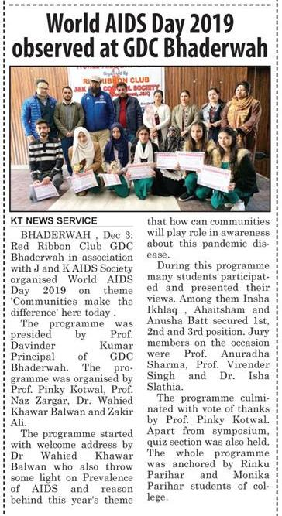
Folk Dance other cultural events BY College students during Sports Festival 2020
https://youtu.be/mC6IwyX2_2A
https://youtu.be/oI0yJ9mWnvk
https://youtu.be/6yIjc31SEtI

https://youtu.be/u5N2jIbHQRY

https://www.dailyexcelsior.com/sports-festival-concludes-at-gdc-bhaderwah/

 | 31 MARCH 2021 |  | RETIREMENT PARTY OF LAB ASSISSTANT MR TAK
 | 01/04/2021 |  | SAVE WATER SAVE LIFE COMPAIGN
 | 05/04/2021 |  | SWARNIM VIJAY VARSH WITH 4 RR BHADERWAH

