IQAC 2020-21

.
NSS/NCC/IQAC Initiatives 2020-21
One Week Online Training-Cum-Workshop on NAAC Quality Aspects inaugurated at GDC Bhaderwah

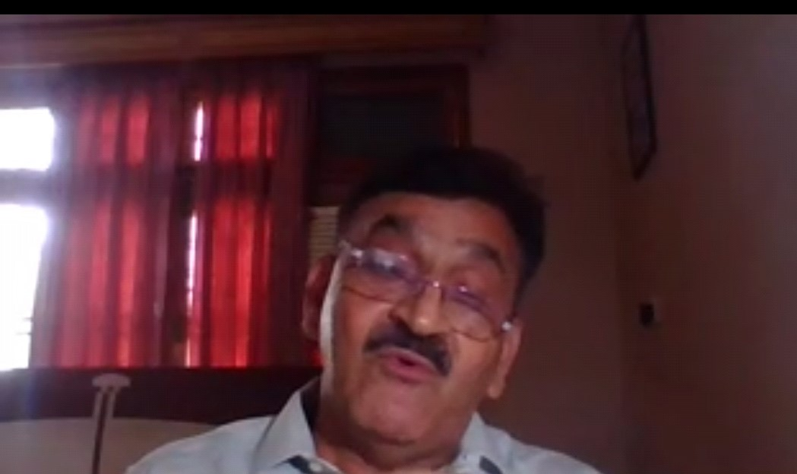

A weeklong online workshop on NAAC assessment and accreditation of affiliated colleges being organized by GDC Bhaderwah was inaugurated today on 13-07-2020.
Presenting welcome address in an online virtual meeting, Dr. KK Sharma Principal GDC Bhaderwah said that NAAC assessment and accreditation is vital for ensuring quality educational services to the students. He said that under the determined leadership of worthy commissioner Secretary Dept.of Higher Education UT of J&K Sh. Talat Pervez Rohella and Director colleges Dr.Yaseen Ahmed Shah, Higher education of J&K union territory has undergone many transformative reforms and modernization. He emphasized on the need of conscious, consistent and catalytic role of faculty in realisation of goals of quality enhancement and sustenance of the college to achieve excellence in all aspects of its functioning.
Prof S.S Balwal ex-Principal of GDC Bhaderwah was keynote speaker on the occasion. It was under his determined leadership that GDC Bhaderwah successfully accomplished the feat of getting re-accredited for cycle-2 by NAAC in march-2019 with B grade.
Prof.S.S Balwal delivered a highly informative and motivational talk to inspire and educate the participants about action plans of NAAC for performance, evaluation,assessment,accreditation and quality up gradation of institutions of higher education. He emphasized on the need of strengthening of IQAC of the college which is a vehicle for ushering in quality enhancement by
working out planned interventionist strategies by removing deficiencies and enhancing quality in all aspects of its institutional functioning.
Prof SS Parihar ,Chief coordinator of the workshop also shared his knowledge and experience of NAAC assessment framework for institutional quality assurance promotion and sustenance.He discussed some key aspects of criteria based NAAC quality assessment framework.
A large number of faculty members from GDC Bhaderwah and from across the colleges of union territory of J&K participated in the online meeting.
The meeting concluded with the formal vote of thanks proposed by Bal Krishan, assistant professor in Zoology.
One Week Online Training-Cum-Workshop on NAAC Quality Aspects Concluded at GDC Bhaderwah:
A one week online training-cum-workshop on NAAC aspects of institutional quality assurance, enhancement and sustenance organized by IQAC, GDC Bhaderwah under the aegis of Dr.K.K. Sharma Principal of the college concluded today .
A large number of teaching faculty from across the colleges of union territory of J&K participated in the workshop. The central idea of organizing such an online training-cum-workshop on NAAC quality aspects was to make the college faculty quality conscious as a part of their professional growth and competence. Quality, which is defined as degree of excellence, holds the key in higher education like in many other aspects of human activity. It is therefore imperative to understand the dimensions of quality to internalize and institutionalize it in various aspects of college functioning.The training-cu-workshop on criteria based NAAC quality assessment framework will certainly strengthen quality consciousness among the faculty and promote quality assurance,enhancement and sustenance in colleges. Expressing his satisfaction on the successful conclusion of the workshop, Dr.KK Sharma Principal of the college said that teachers are agents of social change.We need to develop learning in best possible way and make the colleges as centers of excellence and places of participation. In this hyper connected global world technology is growing fast and education seems to be lagging behind. In this scenario the careers we prepare the students for, may already have become defunct or obsolete by the time they graduate from the college.We therefore need to prepare students for a rapidly changing world and train them to be self-motivated learners who are capable of adapting to new skills, positions, or even entire new disciplines if they are going to be successful after graduation. We also need to promote intellectualism in learners and base learning on sustainability, democracy, values and transversal skills in addition to academics.
The Workshop started with the Inaugural through Zoom and then online course Structure for the Workshop was developed and designed by IQAC of the College for the purpose and was divided into four Modules covering all NAAC aspects .Each module was followed by the learning outcomes, discussions and Assignment questions. The participants actively participated in the workshop by completing all the tasks. The feedback of participants in the training-cum-workshop was quite satisfactory and encouraging.
The principal of the College on the occasion congratulated all the participants for participation and also the organisers for organising the activity on NAAC which important to ensure the Quality culture in the Higher Education Institutions. All the participants shall get e-certificates for the participation and completion of the course.

SWAYAM Prabha and Swayam Awareness:NSS,NCC Units under IQAC initiatives started quarterly awareness compaign on the SWAYAM Prabha and SWAYAM/MOOCs.The students sensitized during the lockdown period for the access to online courses and DTH free 32 Channels services for the graduate and post graduate courses.
GDC Bhaderwah Celeberated Independence Week on 74th Independence Day: On the eve of 74th Independence Day ,the College celeberated Independence Week from 15-21 August 2020 with activity schedules for the week as under: Independence Day Speeches: :15-08-2020 Slogan writing/Painting : 16-08-2020 Role Mahatma Gandhi in Freedom struggle(2page):17-08-2020 India Changing Now:Ideas and Views(1page) :18-08_2020 Audio,vidio Messages Addiction free India links(Self created upto 3Minutes):19-08-2020 National Songs/Poetry(English Hindi,Urdu)(1page) :20-08-2020 Best Performance and participation e-certificates :21-08-2020 In the event 43 students participated and 32 Faculty members attended the event.All the participants were given e-certificates.

GDC Bhaderwah Concludes E-Workshop on Online Admission
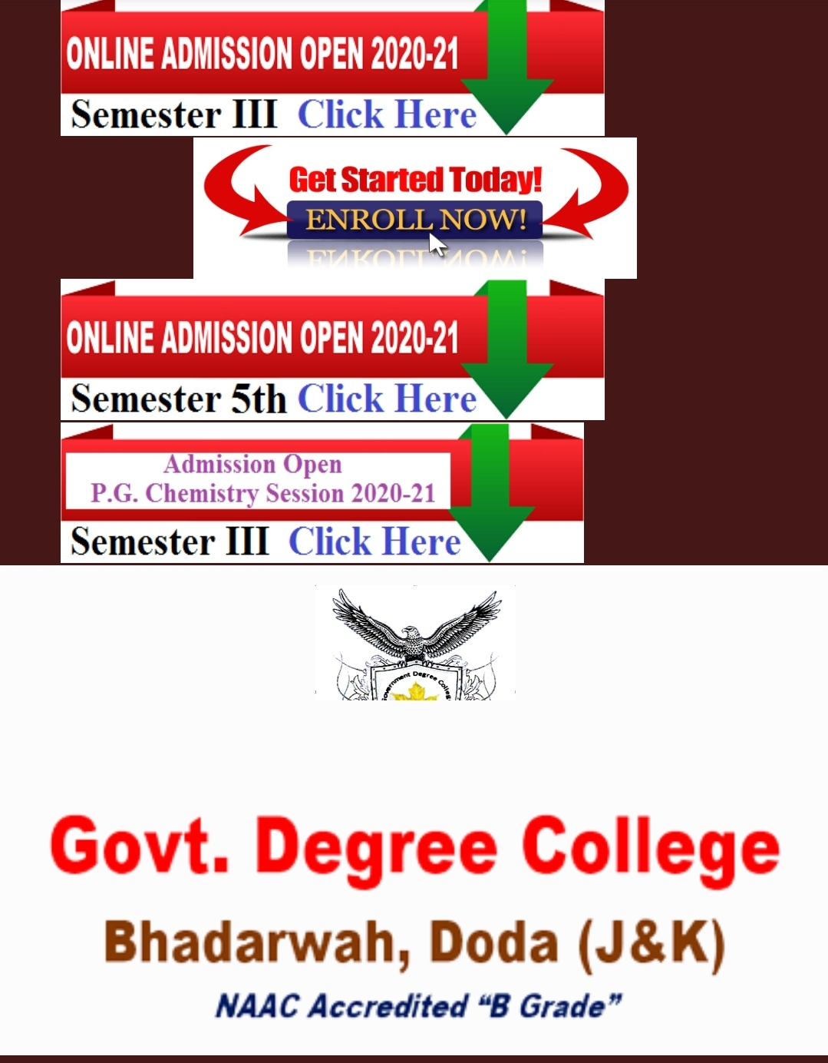
IQAC ,GDC Bhaderwah in collaboration with Pinnacle Technology, MDR organised E-Workshop on Online Admission Process.The purpose of the Workshop was to Train the faculty members and the students as how to handle the online portal for the purpose. The workshop was organised through vidio links ,what’s app group and directly using the portal.The students and the staff were first exposed to the Choice Based Credit System for all the Semesters in general and for the 3rd and 5th Semesters in particular. Then subject Combination provided by the College stream wise and then hands on practice at the portal was provided. The technical sessions on daily basis were handled through what’s app group ,email and telephonically as well.The resource persons for the workshop were Prof Rakesh Kumar,trainer and Prof Surinder Singh Parihar, Convenor, IQAC.The workshop was organized from 26 August 2020 to 16th Sept,2020. The students, staff teaching and non-teaching participated in the workshop and got acquainted with the online admission process.Principal,Dr Kuldeep Sharma congratulated the participants and the organisers Prof Davinder Kumar and Prof Mansa Ram.He thanked the service provider for the quality services and efficient management of the portal.The staff who played active role in process ,trained the students and helped them included Prof Balkrishan,Prof Sandesh Kumar,Dr Reyaz Ahmed,Prof AnkushKProf Manish Kumar,Prof. Pinky Kotwal,Dr Wahied Balwan,Prof Deep Chand ,Prof Deepa Kak,Prof Manjeet Kumar, Dr Sanjay Kumar,Prof Sanjay Kumar,Professor Jai Mala Thakur ,Prof Ashwani Kumar.More than 800 students from PG and UG used the online portal for the admission which helped the students to get admission from anywhere ,from any computer point or from their own smart phones.The fee payment modes were mpay,Google Pay,Paytm etc or even by visiting any bank branch in the vicinity. This facility helped the students and the faculty as well parents and other stakeholders to avoid the personal visits to the college in this COVID-19 pandemic time and thus keeping them stay at homes and stay safe and happy.Seeking feedback from the students and the the staff members regarding the portal ,it was positive and encouraging. The technical support was provided by Prof Arjun Kotwal and Prof Vijay Kumar.

Teachers day celebrated at GDC Bhaderwah with exuberance and gaiety:

To commemorate the teachers day and pay tributes to one of the greatest teachers of all times, staunch eductionist and the second President of India Dr. Sarvepalli Radhakrishnan, the faculty of GDC Bhaderwah organized an online program under the aegis of Dr.K K Sharma Principal of the College today on 5th of Sept 2020.
The format of the proposed activities related to teachers day celebration was circulated previously for the information of students and all other concerned.The program started as per the schedule at 11 am through a ZOOM call meeting. Apart from the faculty members, some student representatives also made it to participate in the program. Prof. S S Balwal, former Principal of the college was keynote speaker on the occasion.The program started with the formal welcome address by Bal Krishan, Assistant Professor in Zoology. In his welcome address, Prof Bal Krishan also gave a brief introduction of the program and emphasized on the need of conscious,consistent and catalytic role of teachers as agents of social change.
Professor S S Balwal, former Principal of the college spoke at length on the role of teachers in shaping the careers of students and their overall wellbeing. He emphasized on the need of professional growth and competence of teachers and need of promotion of intellectualism among the students. He said that we need to base learning on sustainability, democracy and values so that students become self motivated learners with capabilities to adopt to new skills and positions in the fast evolving world. His talk was very enriching and enlightening.
Prof S S Parihar, gave a power point presentation on new education policy.The talk was appreciated by one and all.
The faculty members who actively participated in the zoom call meeting included Prof. Davinder Kumar, Prof. N. K Manhas, Dr. Sandeep Kotwal, Prof. Pinki Kotwal, Prof. Arjun Kotwal, Prof. Deep Chand, Prof. Deepa Kak, Prof. Jai Mala, Prof. Ankush Kumar, Prof. Sandesh Kumar and others.
The program concluded with the formal vote of thanks proposed by SS Parihar, Asstt Professor in economics.

SD/SW NCC UNIT GDC BHADERWAH ORGANIZED NATIONAL WEBINAR ON NEW EDUCATION POLICY2020
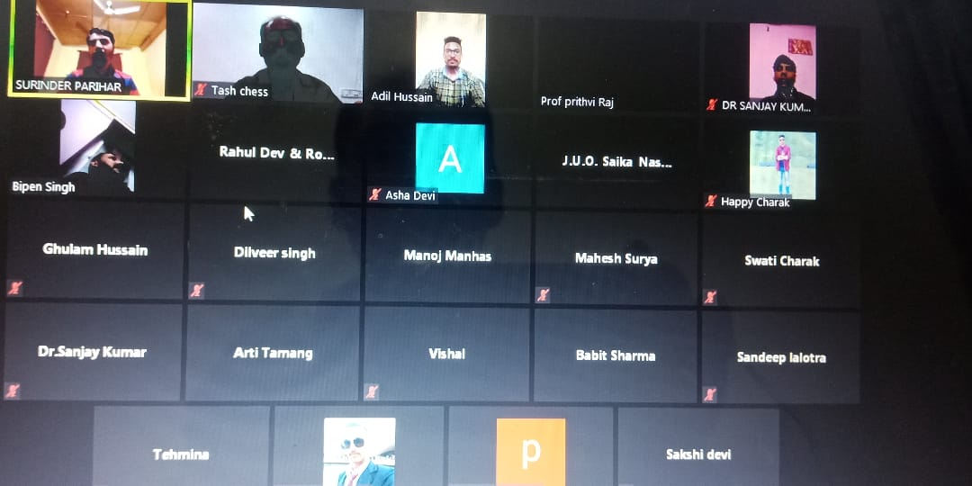

SD/SW NCC UNIT GDC BHADERWAH ORGANIZED NATIONAL WEBINAR ON NEW EDUCATION POLICY2020
NCC unit of Government Degree college Bhaderwah in collaboration with NSS and IQAC organized one day national webinar on new Education Policy 2020 under the aegis of Lt.Col. SS Rawat, Commanding officer 2nd J&K (I) coy NCC unit Bhaderwah and Dr Kuldeep Sharma , Principal GDC Bhaderwah. Prof Prithvi Raj, ANO SD/SW NCC unit of the college gave the welcome address and underscored the importance of National webinar on the New Education Policy which is an improvement over the National education Policy 1968 and 1986. He also elaborated the role of NCC in NEP 2020. The key resource person for the webinar was Prof. S.S Parihar who highlighted the structure of the NEP 2020and its implementation through the power point presentation by explaining the 5+3+3+4 structure up to 12th level and next four years for college level, then for Post-graduation and finally getting Ph. D. New Policy is paradigm shift and emphasis on the holistic development of the learners. He further said that the policy shall not be implemented in one go but through steps and by 2030 it shall be fully implemented to make India as global hub for the education. The other Presenter were cadet Sandeep Lalotra of SD NCC GDC Bhaderwah and cadet Asha Devi from SW NCC GDC Kishtwar, who in their presentation explained the relevance of the new education policy and how NCC can be helpful in implementation of NEP2020. the webinar was attended by different faculty members and 50 cadets from different colleges across the union territory of Jammu & Kashmir. The prominent present on the occasion were Mr. Gh Hassan , Hawaldar 2nd J&K(I) coy NCC Bhaderwah, DR Sanjeev Koul ,ANO HS Bhalra , Prof Sanjay Katal, Prof Sanjay Kumar , Prof ANU Sharma , Prof Bipan singh . The proceedings of the webinar were conducted by JUO Siaka Nasser and the formal vote of thanks was presented by SUO Arti DeDevi.
Sd/
Principal,
,GDC Bhaderwah

Hindi Diwas Celebrated at GDC BHADERWAH
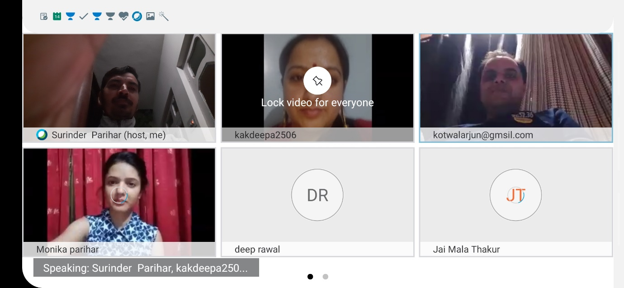

Department of Hindi in collaboration with NCC,NSS and IQAC ,GDC Bhaderwah organised t
a grand event through Cisco Webex under the aegis of Dr Kuldeep Sharma ,Principal of the College. To start with the Programme Prof. Rabinder, Head ,Department of Hindi GDC Bhaderwah gave briefings on the programme and Miss Rinku Parihar gave the Welcome address . There were seven student speakers namely Mr Arjun,Mr Sawan,Mr Pardeep,Miss Shallu,Miss Rinku ,Miss Monika and Miss Manisha on the occasion.The students presented their papers on why the day is important and why it is celeberated. The presenters threw ideas on how Hindi was made as a National language on 14 sept .1949 and since then every year it is celebrated as Hindi Diwas.The language is spoken globally and ranks 4th in order at the International level.It is pertinent to mention here that even Mahatma Gandhiji advocated in 1918 to make Hindi as a National language. As India is a country of diversity and various languages are spoken in the country and they too change in different states and districts. Hence one India becomes possible through Hindi,because it is the only medium through which all citizens of the country do connect and Express each other.All the Faculty members presented their ideas on the occasion. Professor Rabinder, HoD Hindi presented his views on the importance of Hindi Diwas,importance of of the National language and Career options for the Hindi Graduates. On the occasion Professor, S.S.PARIHAR highlighted the need for speaking and promoting the language for the citizens. Dr Sharma congratulated the organisers for celebrating the occasion and motivated the learners to work of the development of the language which our National language and connect us globally.. The prominent faculty members who attended the session were Prof Davinder Kumar, Prof Arjun Kotwal, Prof Prithvi Raj,Prof Deep Chand,Prof Pinky Kotwal,Prof Deepa Kak,Prof Jai Mala Thakur, Dr Tasir,Prof Bekham Paul,Prof Ajay and others.More than 18 students attended the session. All the participants got e-certificates for the participation .The event concluded with a vote thanks by Miss Monika ,student from Department of Hindi.

World Ozone Day Celeberated at GDC Bhaderwah
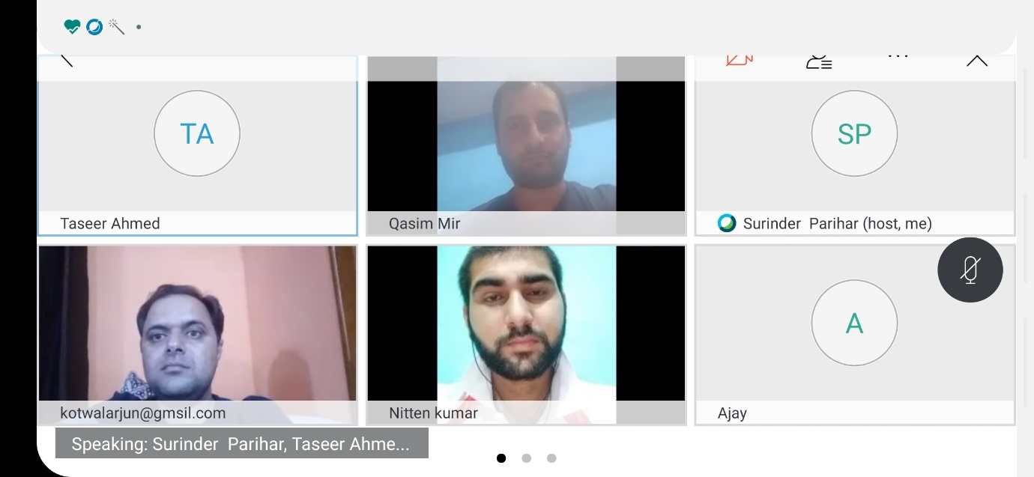

Department of Geography, Environmental Sciences and Economics in Collaboration with NSS, NCC and IQAC organised a grand event through Cisco Webex meet under the aegis of Dr Kuldeep Kumar Sharma, Principal of the College. To start with the event Professor S.S.Parihar gave the briefings of the Programme. Professor Taseer Ahmed presented the welcome address. There were five student speakers namely, Sana Irshad Tak, Manoj Kumar, Bilal Ahmed, Insha Ikhlaq,Rinku Parihar and Nitin Kumar who spoke on different aspects of the Ozone Depletion and ways out.The theme for the Ozone Day 2020 was Ozone for life and on the basis this theme presentations were made by the presenters. Student presenters drew the attention of one and all by their innovative ideas and views on the theme. Dr. Anu Sharma from Department of Environmental Sciences gave presentation on the occasion and explained the different aspects of this serious environmental problem. She also talked of different accords as Montreal Protocol 1987, Kyoto 1997 and Paris Accord 2016 on Environmental Aspects. Last presentation was made by Professor Qasim Mir, Head Department of Geography. He focussed on depletion as well as healing of Ozone layer. He also talked of Northern and Southern Hemispheres and shifting of Jet stream and geographical phenomenon. It is pertinent to mention here that Ozone layer is a protective layer in the atmosphere and is measured in Dobson Units as 100 Dobson Units mean 1millimeters and average thickness of this shield is 3mm that two coins of Re1 stacked together.The session was very interactive as different queries were raised by the students and the faculty on the occasion and were answered by the Resource persons Professor Anu and Prof Qasim Mir. The principal of the college expressed his satisfaction over the conduct of such an event of Global importance and congratulated the organisers and the speakers especially the students speakers who made wonderful presentation on the occasion. He assured that all the participants shall get e-certificates for the participation and presentations of their papers. The prominent faculty members who attended the session were Prof Davinder Kumar, Prof Arjun Kotwal, Prof Prithvi Raj,Prof Deep Chand,Prof Pinky Kotwal,Prof Deepa Kak,Prof Jai Mala Thakur, Dr Tasir,Prof Bekham Paul,Prof Ajay and others.More than 20 students attended the session. The event concluded with a vote thanks from Professor Taseer Ahmed from Department of Geography.

NSS Raising Day” organised on at GDC Bhaderwah
Department of Economics celebrated“NSS Raising Day” on 24-09-2020 in collaboration with NSS,NCC and IQAC ,GDC Bhaderwah through Cisco Webex Meet under aegis of Dr Kuldeep Sharma ,Principal of the College.To start with the Programme ,Professor S.S.Parihar,HOD ,Economics gave the power point presentation in which he highlighted the aims and objectives of the National Service Scheme which is operated by Ministry of Youth Affairs and Adventures.He elaborarated how volunteers play an important role in educational,social, rural ,environmental and other services. Further how they participate in National integration Camps,Republic Day Camps and other Adventures as well as National Youth Festivals to get acquainted with rich culture,diversity and heritage of the Nation and develop spirit of Nationalism, patriotism, leadership, administrative skills and discipline as well as to understand the nature of humanity and become ready to serve the Nation 24/7 during natural calamities or other disasters. Speaking the occasion Professor Prithvi Raj motivated the the students to participate in NSS and NCC as it helps them a lot.Professor Davinder Kumar highlighted the importance of NSS and counted various experiences during his tenure as NSS,Programme Officer,Prof Anu on the occasion shared her experiences as NSS volunteer during her college days,Prof ArjuonKotwal shared his experience of SBSI 2018 at Diggi Village Bhaderwah, Prof Rabinder also shared his ideas on the virtual platform. The students raised different queries at the end of the session which were responded by the staff members .The prominent among others present were Professor Sanjay,Prof Deepa Kak,Prof Jai Mala Thakur,Mr Anil,Miss Rinku,Mr Aslam .The Programme ended with a vote of thanks from Prof S.S.Parihar,PO,NSS.

Sd/
Principal,
GDC BHADERWAH

GDC Bhaderwah Organized Gandhi Jyanti Week 2020
Departments of Education, Sociology, Economics in collaboration with NSS,NCC and IQAC ,GDC Bhaderwah organised Week long event on Gandhi Jyanti from 26 Sept,2020 to 2nd Oct,2020. The activities for the event were essay writing Competition, painting and posters Competition, Quiz competition and the live Interaction with presentations through Webex Meet.The students posted there entries through the links provided, participated in online quiz and the last activity where paper presentations were made by the students and the faculty members.The students who made their presentations live were Miss Saika ,Miss Rinku,Miss Monika,Mr Sandeep Lalotra,Miss Arti and the faculty members included Prof Deepa Kal,Prof Jai Mala,Dr Anu Sharma ,Prof Prithvi Raj and Prof Surinder SiVariParihar.The presentations were made on Gandhiji’s teachings,Education, Trusteeship Doctrine, Principles of life and other related themes.The event was organised under Quality initiatives of Higher Education and NAAC.Speaking on the valedictory Dr Kuldeep Sharma,Principal of the college congratulated the organising committee members Prof Deepa Kak,HoD ,Education ,Prof Jai Mala,HoD ,Sociology and Prof Surinder Parihar,Convenor, IQAC.The prominent staff members who attended participated in the event were Prof Sanjay Kumar,Prof Varinder Kumar,Prof Arjun Kotwal.50 students took active participation in the event.All the participants were given e-certificates. The proceedings of the programme were conducted by Miss Saika Naseer and the vote thanks was presented by Miss Rinku Parihar
The event wise results are :
1.Essay Competition: Miss Divya Thakur , GDC Bhaderwah 1st Position
Miss Sumaiya Banoo, GDC Bhaderwah 2nd Position
Mr Atif Ali Zakir , GDC Doda 3rd Position
2.Posters/ Paintings:Mr Muzamil
Miss Sumaiya
Miss Hem Nalni
3.Slogan Writing:Mr Muzamil
: Miss Sumaiya
4.Quiz Competition on Gandhiji's Ideology:Mr Muzamil ,Miss Sumaiya, Miss Arti,Mr Mohit Rukwal,Mr Sande\ep Ist Position
:Mr Furqan,Miss Saika 2nd Position
: Mr Nitten Kumar,Mr Ajay Parihar,Miss Shreya 3rd Position
5.Paper Presentations:Miss Rinku 1st Position
:Mr Sandeep,Miss Saika ,Miss Monika,Miss Arti 2nd Position

Sd/
Principal,
GDC Bhaderwah

GDC Bhaderwah Organized One Day National Webinar on Financial Awareness and Consumer Training

GDC Bhaderwah Organized One Day National Webinar on Financial Awareness and Consumer Training in collaboration with National Centre for Financial Education(NCFE).A large number of Faculty and students participated from across J and K and India .The Webinar started with the formal welcome address by Mr. Surinder Singh Parihar,Assisstant Professor in Economics and Convener ,IQAC GDC Bhaderwah. In his welcome address Professor Parihar gave a brief introduction about the topic of Webinar and spoke on the significance of the same in the modern scenario of digitalization and globalization .He said that during COVID-19 pandemic times where every aspect of human activity is shifting to online /virtual mode, we should be informed and educated about the online financial transactions, digital currency and block chain technology .He further said that literacy on online financial transactions during the pandemic times minimizes the use of currency and contact to surfaces ,thus reducing the intensity of virus transmission of the disease .The online transaction mode also ensures transparency and discourages money laundering and black economy. Mr. Sabzar Ahmed,Trainer for Financial Management and Consumer Affairs J&K gave an expert talk on the subject matter .He covered all aspects of financial aspects and consumer affairs in his highly informative and enriching talk. Through a power point presentation Mr. Sabzar gave a comprehensive demonstration about financial planning, budgeting, financial instruments, assets and financial services. He also stressed upon the safety measures to be adapted while going for online/offline financial transactions. The Webinar was presided over by Dr K.K.Sharma,Principal GDC Bhaderwah.He congratulated the organizers and the participants especially the resource person Mr. Sabzar Ahmed ,Trainer at NCFE ,for bringing up the crucial topic which touches upon the lives of everyone in a significant way. In his virtual address to the audience ,Dr Sharma gave a brief account of the topic of Webinar and said that finance is the management of money and includes activities such as investing, borrowing, lending, budgeting, saving, and forecasting and that there are three main types of finance: personal, corporate, and public/government. Financial literacy is more important than ever as financial instruments, assets and transactions are undergoing transformative shifts with the introduction of digital currency and block chain technology. He said that people manage their own retirement accounts, trade personal assets online, and carry credit cards and mortgage debts etc. As such they must have basic education and awareness about financial management. He urged upon the teaching of basic financial contents /skills to all undergraduate level students across the spectrum of disciplines and courses for a large scale financial awareness. The programme was efficiently compered by Dr Anu Sharma,Lect. Department of Environmental Sciences. The webinar concluded with the vote of thanks proposed by Ms Deepa Kak,Assisstant Prof. in Education.

Sd/
Principal,
GDC Bhaderwah

GDC Bhaderwah Organized National Wildlife Week 2020
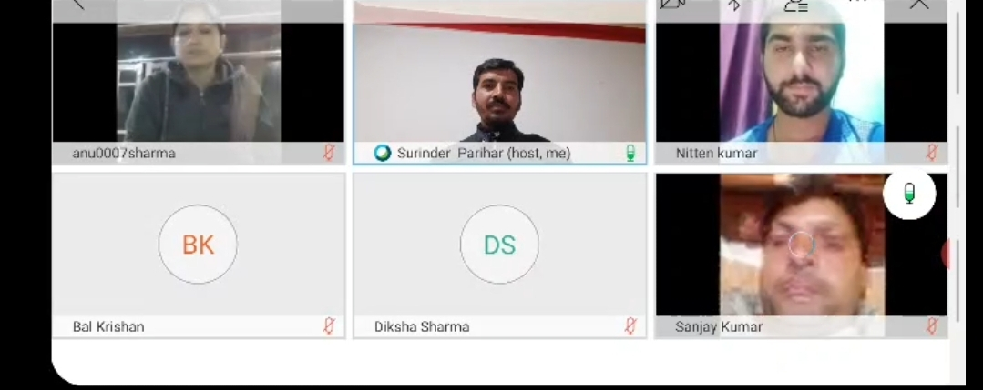

GDC Bhaderwah Organized National Wildlife Week 2020
Departments of Environmental Sciences in collaboration with NSS,NCC and IQAC ,GDC Bhaderwah organized National Wildlife Week 2020 from 01 Oct,2020 to 08 Oct,2020. The activities for the event were essay writing Competition, painting and posters Competition, Quiz competition and the live Interaction with presentations through Webex Meet.The students posted there entries through the links provided, participated in online quiz and the last activity where paper presentations were made by the students and the faculty members.The students who made their presentations live were Miss Amesha Devi,Mr Nitten,Mr Sajid,Mr Brij Mohan,Mr Gulzar and Mr Waseem Raja ,the faculty members included Prof Deepa Kal,Prof Jai Mala,Dr Anu Sharma ,Prof Prithvi Raj and Prof Surinder Parihar.The presentations were made on how to protect the wild life, biodiversity, environmental and other related themes.The event was organised under Quality initiatives of Higher Education and NAAC. Prof Mohrana Chowdhry from Guwahati,Assam joined the even as guest and presented his views on the occasion. Speaking on the valedictory Dr Kuldeep Sharma,Principal of the college congratulated the organising committee members Dr Anu Sharma for the efficient Management of the week long event and Prof Surinder Parihar,Convenor, IQAC for coordinating the activity.The prominent staff members who attended participated in the event were Prof Sanjay Kumar,Prof Varinder Kumar,Prof Arjun Kotwal,Dr Sandeep Kotwal,Prof Diksha Sharma,Prof Sanjana,Prof Quasim,Prof Bal Krishan,Prof Pinky Kotwal,Prof Deepa Kak,Prof Prithvi Raj among the others. More than 100 students took active participation in the event.All the participants were given e-certificates. The proceedings of the programme were conducted by Prof Anu Sharma,Department Environmental Sciences and and the vote thanks was presented by Mr Nitten Kumar
The event wise results by Judges are:
1.Posters/Painting Competition:
Mr. Nitten Kumar,GDC Bhaderwah 1st Position
Miss Sumaiya Banoo, GDC Bhaderwah 2nd Position
Miss Divya Thakur , GDC Bhaderwah 3rd Position
Judges: Prof Sandesh, Prof ,Prof Qasim Mir and Prof. Prithvi Raj
2.Essay Writing
Mr Sanjay Kumar,GDC Thathri 1st Position
Mr Mazamil Ahmed ,GDC Bhaderwah, 2nd Position
Miss Divya Rathore ,GDC Bhaderwah 3rd Position
Judges: Dr Wahied Balwan,Dr Anu Sharma

4.Quiz Competition on Wildlife Protection/ Biodiversity
Mr Muzamil ,Miss Sumaiya, Miss Arti,Mr Mohit Rukwal,Mr Muzamil Ahmed,Miss Shreya,Miss Sumaiya,Mr Fareed, and Miss Anita, Ist Position
Mr Nitten Kumar,Miss Rinku Parihar,Mr Surjeet Kumar,Miss Priya 2nd Position
Mr Vishwajit Singh,Mr Ajay Parihar 3rd Position

Sd/
Principal,
GDC Bhaderwah

Bhaderwah organised one day Webinar on " Teachings of Gurunak Devji":
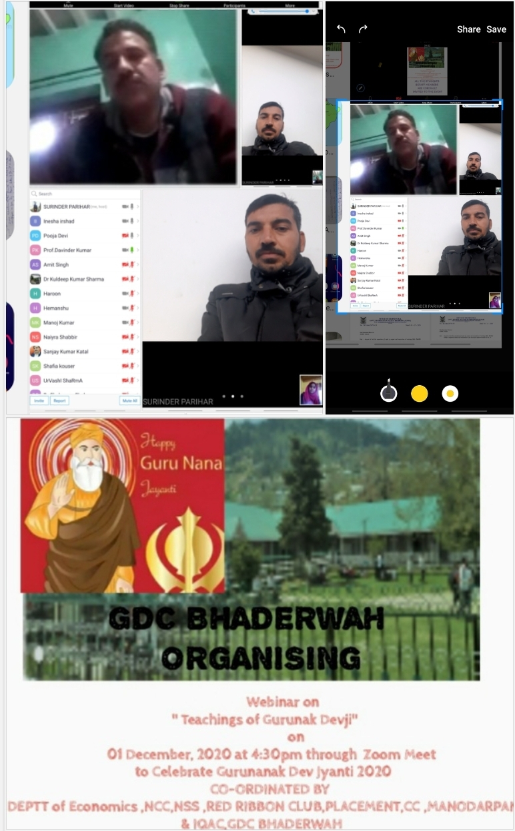
Department of Economics in collaboration with NCC,NSS ,RED,GDC Bhaderwah organised one day Webinar on " Teachings of Gurunak Devji" today 01 December, 2020 at 4:30pm through Zoom Meet to Celebrate Gurunanak Dev Jyanti 2020.The Programme started with a welcome address by Prof S S.Parihar ,HoD Economics,who gave the Briefings of the Webinar ,its relevance and impact on day today life in present context.There were four students who presented their papers on the theme were Miss Pooja,Mr Sadiq,Miss Anesha and Miss Tehmima.The students highlighted the spiritual philosophy of the Guru.Different faculty members presented their ideas on the occasion .Concluding remarks were presented by Professor Davinder, HoD Botany who appreciated the participants and congratulated them.The principal of the College Dr Kuldeep Sharma in his address focussed on relevance of Guru and Spirituality in lives of the people and he felt happy over the presenters on their messages and said that spiritual philosophy should reach to the common masses. 20 students and 10 faculty members attended the Webinar. The prominent present on the occasion were Pr Naz,Prof Prithvi Raj ,Prof Katal,Dr Rashid .The event ended with a vote of thanks proposed by Mr S.S.Parihar.

Constitutional Week Kick started at GDC Bhaderwah
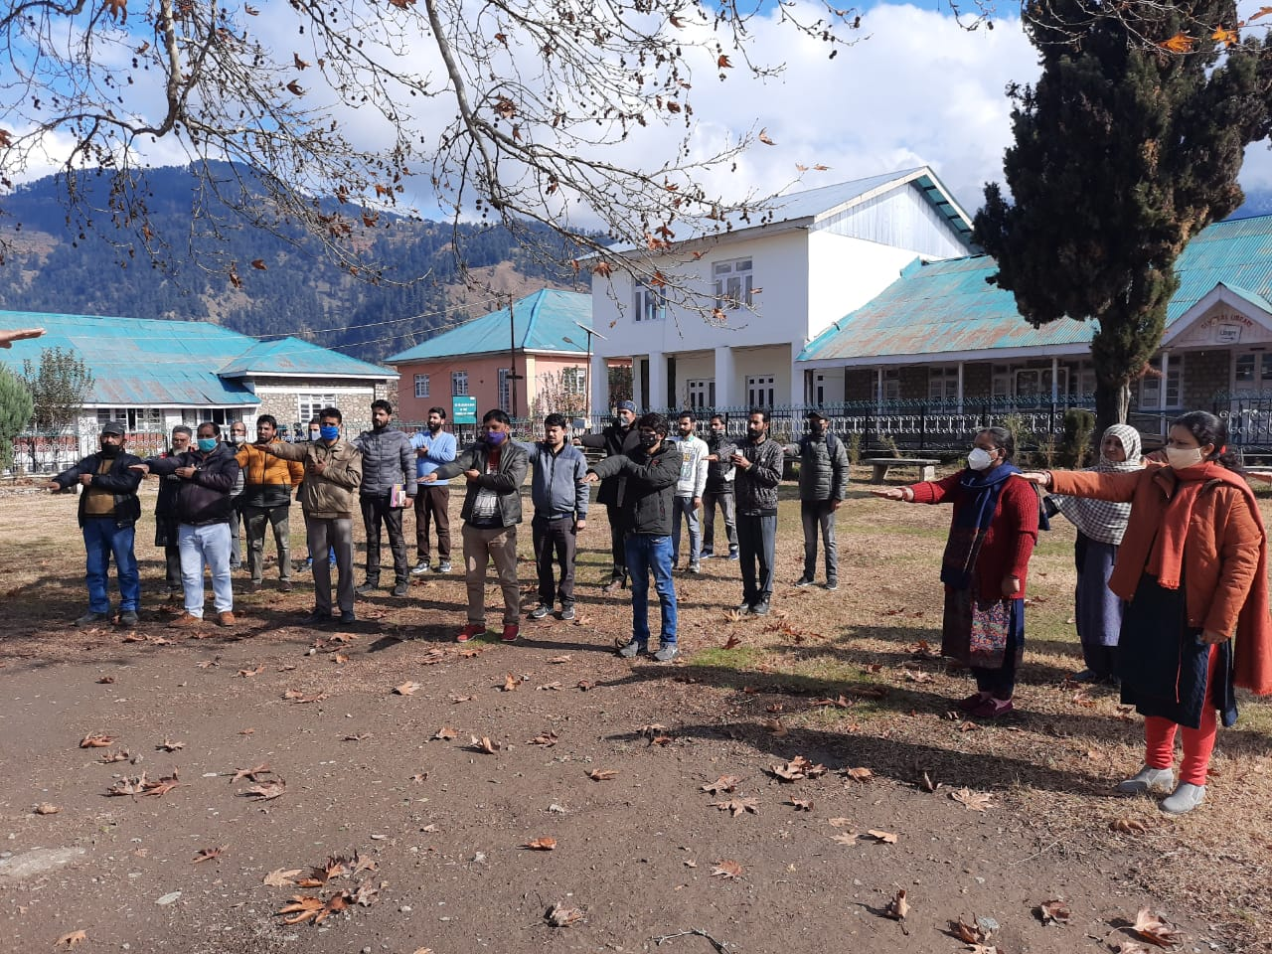

.
IQAC, GDC Bhaderwah in collaboration with Deptt of Political Science, NCC, NSS and Red Ribbon Club, Placement, Career Counseling and Manodarpan Cell of the College organized the inaugural event on Constitutional week to be organized from 26 Nov to 01 December, 2020. The purpose of the event was to instill the ideas of fundamental rights and duties of amongst the faculty members and the students as how to make the citizens of the country aware on the Constitutional aspects. The event was inaugurated through video Webex Meet online for the staff and the learners for the live interactions and idea presentation and pledge to abide by the Constitutional values and ideals. The students who made their presentation on the occasion were Mr. Faizan Malik, Miss Sana Irshad Tak, Miss Tabida and Mr. Sandeep respectively. The important constitutional aspects covered during presentations were Preamble, Directive Principles of State Policy, Fundamental Rights and Fundamental Duties. The students are also expected to participate in other events as per the Schedule shared with them. The prominent staff who attended the event include Prof. Davinder Kumar, Prof. N.K Manhas, Prof Sandesh Kumar, Prof Ankush, Prof. Manish Kumar, Prof. Pinky Kotwal, Prof. Deepa Kak, Prof. Manjeet Kumar, Prof. Jai Mala Thakur, Prof Ashwani Kumar, Prof Prithvi Raj, Prof. Sanjay Katal, Dr. Taseer Nawaz, Bipan Singh, Rameshwer Singh, Shoket Ahmed and others. Among the non-teaching staff members present on the occasion were Mr. Liaqat Ali, Mohd Afzal, Rajinder Kumar, Tahira Begum, Omesh Kumar, Sunil Kumar, Hans Raj, Joginder Lal, Hamid Khan, Nusrat Begum, Ajay Kumar, Rahila. The technical support was provided by Prof. Arjun Kotwal and Prof. Vijay Kumar. All the participants shall be given the e-certificates. Speaking on the occasion Principal of the college, Dr. Kuldeep Kumar Sharma underscored the importance of organizing events of National relevance and keeping the students aware and instilling the awakening amongst them. He congratulated the organizers especially Prof. Sanjay Kumar and Dr. Layeeq Sheikh for taking this initiative. He also thanked all the participants. The event concluded with the reading of the Preamble and Pledge taken offline in the college campus. A formal vote of thanks by Prof. S.S Parihar.

Sd/-
Principal
Govt. Degree College
Bhaderwah

Workshop on Internship and its Importance Organised ON 08-12-2020

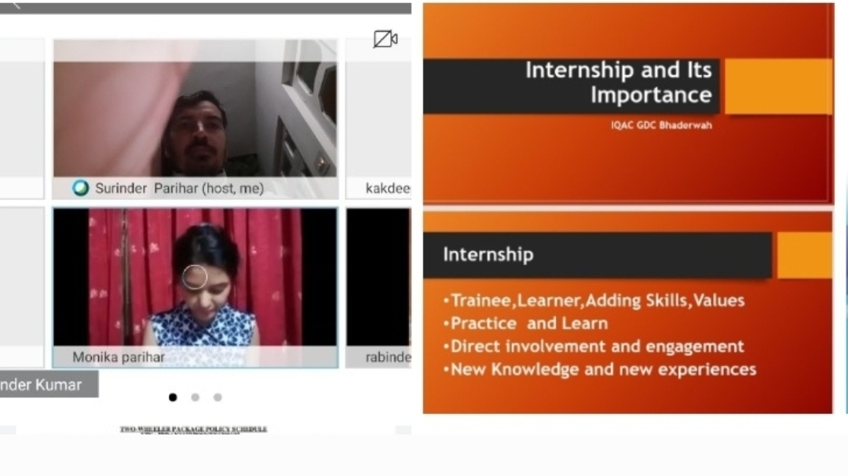

Republic Day celebrated at Bhaderwah 2020:
:
https://youtu.be/lRQww9PghmE
NCC cadets participation
https://youtu.be/RSxEZgwYoMw
Cultural Progarmme

Dance perform at gdc bhaderwah (sports festival 2020)

https://youtu.be/mC6IwyX2_2A

Tribute to Jalaiwala Bagh martyrs by NCC Cadets of Bhaderwah ON 13 APRIL 2021

KINDLY VISIT AT:
https://youtu.be/wY280UB5Sfo

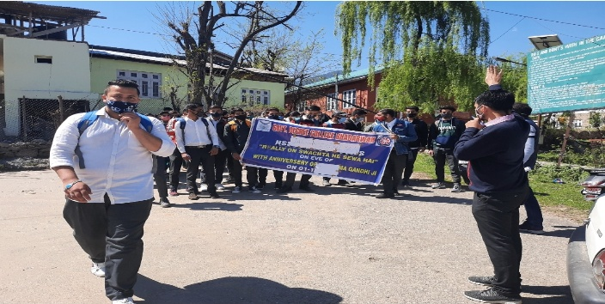
SAVE JAL RALLY 04-04-2021

VIJAY VARSH COMMEMORATING 1971 VICTORY ORGANISED AT GDC BHADERWAH ON O5-04-2021
VISIT HERE PL. TO WATCH :
https://youtu.be/rXI7jyDBVJw

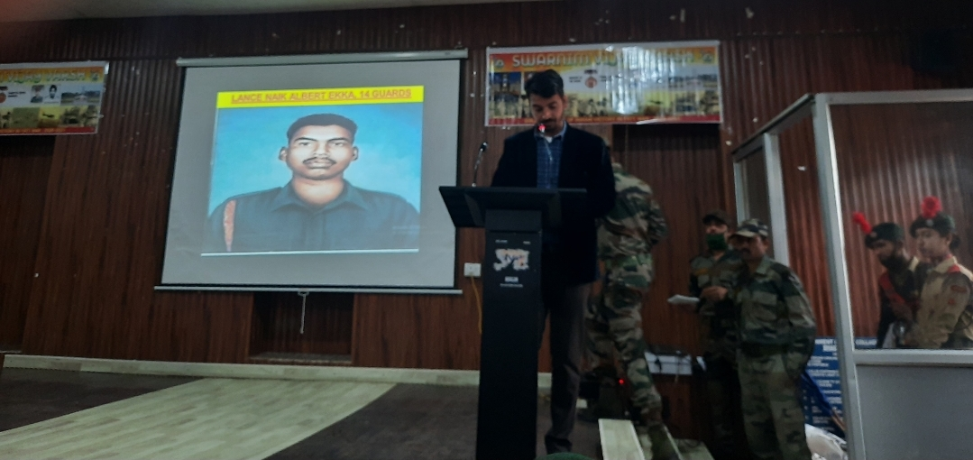
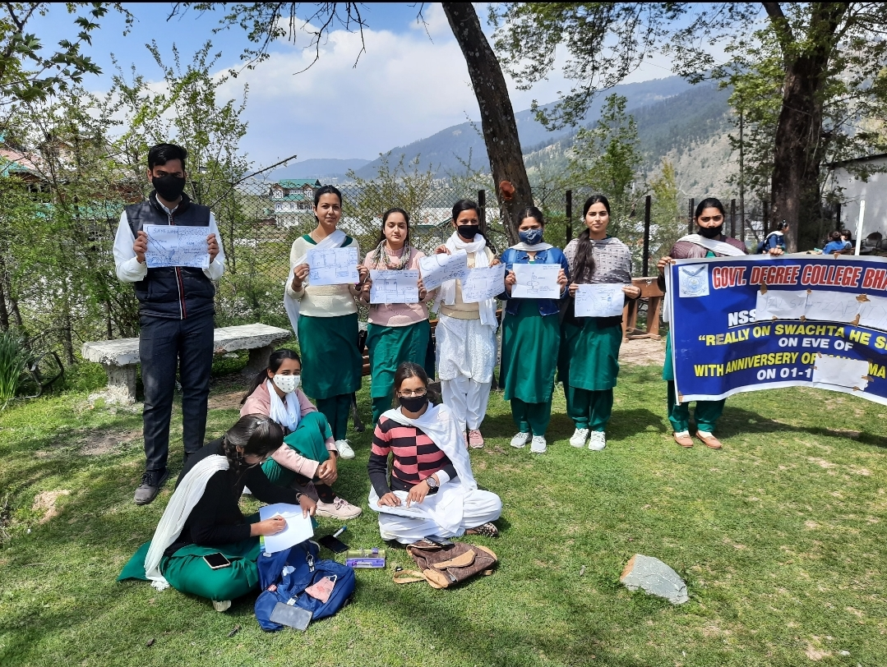
POSTER COMPAIGN ON JAL SARANKHSHAN ORGANISED AT GDC BHADERWAH 06-04-2021 :

Department of Environmental Sciences and department of Botony of Govt Degree College Bhaderwah ON 90-04-2021:

KINDLY VISIT HERE AT LINK:

https://youtu.be/zVsx0F2XSk4

https://youtu.be/ls0j8jsHf6E

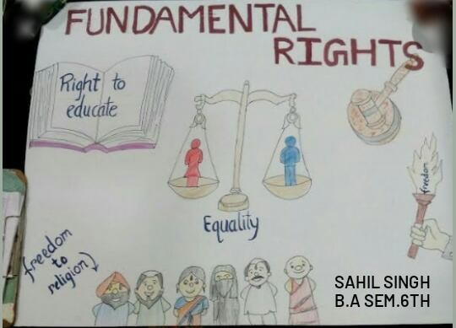
AWARENESS PROGRAMME ON FUNDAMENTAL RIGHTS ORGANISED AT GDC BHADERWAH

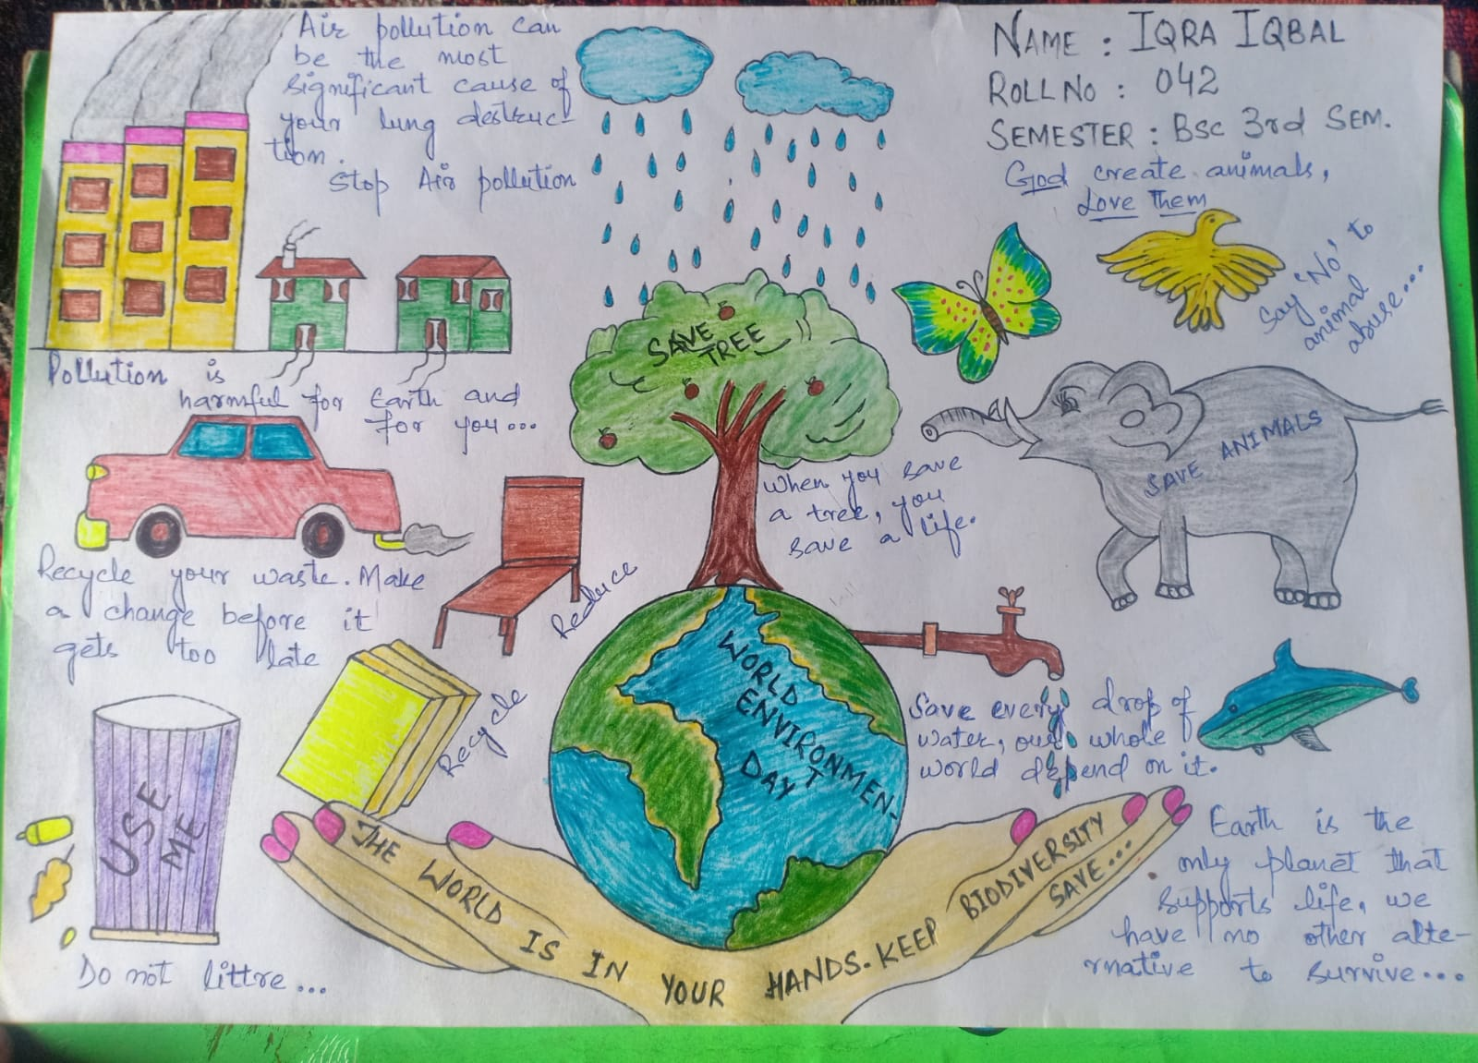
World Environment Day Celeberated at GDC Bhaderwah
NSS,NCC and IQAC GDC Bhaderwah organised online week long event from 31 May to June 05,2021 on the occasion of World Environment Day 2021 with the theme “Recreate,Reimagine and Restore.The students of the college participated in different activities as audio,vidio clips,pamphlets poetry ,poster making and worked on different themes as save trees ,save life ,Conserve natural resources,shifting to renwable sources of energy ,greening mother earth.The platforums to share the contributions was whats app and face book.To conclude the event live interaction through Zoom online platforum was arranged where the students and staff members attended the programme and gave their valuable insights.The key resource person for the event was Dr Anu Sharma ,Lecturer Deptt. Of Envirnmental Sciences who made her power point presentation and drew the attention of the audience towrads the growing menace of the environmental threats and the ways out to solve the problems.The students speakers Mr Sandeep,Mr Anil,Miss Pooja,Miss Sheetal,Miss Komal, Miss Sonali made excellent presentations on the occasion and highlighted different aspects of the Nature and the Environment to make the mother earth most beautiful.Present on the occasion Prof Prithvi Raj ,ANO NCC laid the emphasis on plantation drives,Prof S,S,Parihar focussed on Sustainable Development Goals and commitmrent of the World leaders and Prof Davinder Kumar HOD ,Deptt of Botany motivated the students to contribute more towards the conservation compaign.In the concluding remaks,addressing the students and the staff,Dr Kuldeep Kumar Sharma appreciated the students efforts during the week long event and he stressed upon all the department to get involved and engage students in different events and activities.He appreciated the organising team and congratulated all the participants.Encourging the students ,he emphasised that students should participate actively in the non-academic activities.The proceeding of the programme were conducted by Pr S.S.Parihar ,PO,NSS GDC Bhaderwah .The event ended with a vote of thanks .

Food Security and Safety Week Observed at GDC Bhaderwah
NSS,NCC,RRC and IQAC GDC Bhaderwah organised online week long event from 07 -13 June 2021 on the occasion of of World Food Safety Day 2021 with the theme “safe food for healthy tomorrow.The students of the college participated in different activities as audio,vidio clips,pamphlets poetry ,poster making and worked on different themes as food security ,save food ,Shift to organic food,shifting to biofertilzers .The platforums to share the contributions was whats app and face book.To conclude the event live interaction through Teachmint platforum was arranged where the students and staff members attended the programme and gave their valuable insights.The key resource person for the event was Prof S.S.Parihar ,PO ,NSS GDC Bhaderwah who highlighyted differednt aspects of the Food Security and Safety in India and the World .He drew the attention of the audience towards the growing menace of the hunger ,malnutrition and starvation deaths in different poor economies of at global level.The students speakers Mr Saleem and Miss Sonika made beautiful presentation on the occasion and strived for extending helping hands towards the poor and the needy during this pandemic times and the role of the students in the compaign to avoid the food wastage and share the extra food with others.In the concluding remaks,addressing the students and the staff,Dr Kuldeep Kumar Sharma appreciated the students efforts during the week long event for their active participation .He appreciated the organising team and congratulated all the participants.Encourging the students ,he emphasised that students should participate actively in the non-
academic activities.The proceeding of the programme were conducted by Pr S.S.Parihar ,PO,NSS GDC Bhaderwah .The event ended with a vote of thanks

Two Days Event on World blood donor day Concludes at GDC Bhaderwah
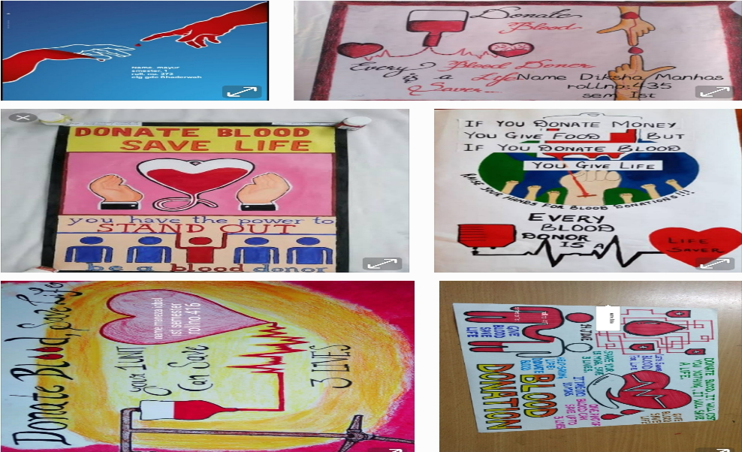
NSS,NCC,RRC and IQAC GDC Bhaderwah organised online two days event 0n 14 and 15 June 2021 on the occasion of of World Blood Donor Day 2021 with the theme “Give Blood & Keep the World Beating”.The students of the college participated in different activities as audio,vidio clips,pamphlets ,poster making relating to the theme .The platform to share the contributions was whats app and face book.To conclude the event live interaction through Teachmint platform was arranged where the students and staff members attended the programme and gave their valuable insights.The students participated actively in the compaign. In the concluding remarks,addressing the students and the staff,Dr Kuldeep Kumar Sharma appreciated the students efforts during the two days event for their active participation .He appreciated the organising team and congratulated all the participants.Encourging the students ,he emphasized that blood donation is a great noble cause and we all should come forward on voluntary basis to save lives and contribute towards to the blood bank .The programme was organissed under the supervision of by Pr S.S.Parihar ,PO,NSS GDC Bhaderwah .The event ended with a vote of thanks .

INTERNATIONAL YOGA DAY CONCLUDES AT GDC BHADERWAH
IQAC GDC Bhaderwah in collaboration with NCC , NSS and 2nd JK (I) Coy NCC Bhaderwah organized week long event on international Yoga Day 2021 with the Theme “ Be with Yoga , Be at Home” from 14 -21st June 2021. Live Yoga session was organized on IYD 2021 in which SUO Manoj , cadet salooni & cadet Shivani acted as master trainers and the cadets ,students, staff, ANOs and many families and other guests followed them while performing Yoga exercises and Yoga Asaanas. The session was very enjoying as participants performed Yoga with their families. Main Asaanas performed on the occasion were Tar Asaana, Bhujang asana, uttaasana, chatruranga asana, etc in addition to breathing exercises as anulom, viloum(inhale/exhale).
Kick starting the event on 14th June NCC cadets & NSS volunteers participated in poster competition, jingle competition , yoga asana competition , yoga speech competition , online quiz organized by Ministry of AYOUSH. These competition were based on the different themes for IDY2021 like Yoga and Nature,Yoga and Health , stay with yoga stay with family, Yoga for wellness etc. All these activities were carried out through whatsapp groups for the purpose and online live performances via google meet.
Lt Col S S Rawat , Guest of Honor on the occasion congratulated the cadets ,staff students and ANOs from different institutions. He inspired and motivated the students especially cadets and appreciated their performances during event, and promised to convey the same with higher authorities. Dr Kuldeep Kumar sharma , principal of the college and chief guest for the day commended the participation of the NSS,NCC and other students of the college and different institution , for the week long drive. He congratulated IQAC, NCC, NSS for organizing this event. Earlier welcome address was presented by Lt/Prof Prithvi Raj ANO NCC . HE also acted as moderator for the event . Mrs Anu adha , Cultural Ambassador Doda & teacher at NPS Durga Nagar also participated in the session with students of her school. Prominent present on the occasion were Prof Devinder kumar, Prof Mansa ram, Prof BP Chouhan, Prof SS parihar , Prof Arjun kotwal, Prof Manjeet , CTO Ranjeet,captain Vineet ANO, Lt Madhu ANO,Mr Asif , Lt Naseem ANO, Dr Ashok ANO and staff members of 2nd JK(I)Coy NCC Bahderwah and ANOs from different institution with family members of the cadets . The event ended with a formal vote of thanks by Prof SS Parihar , PO NSS GDC Bhaderwah.

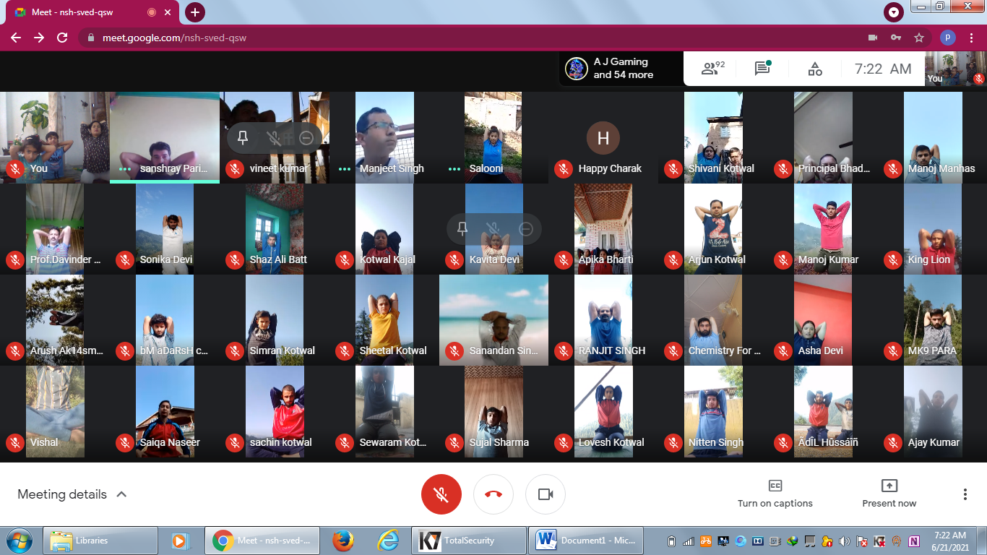
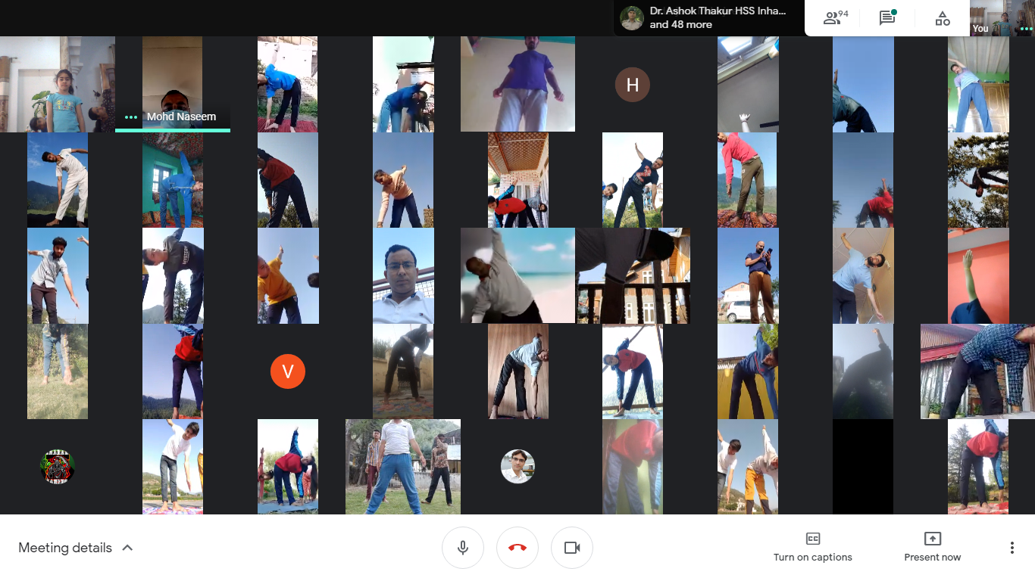

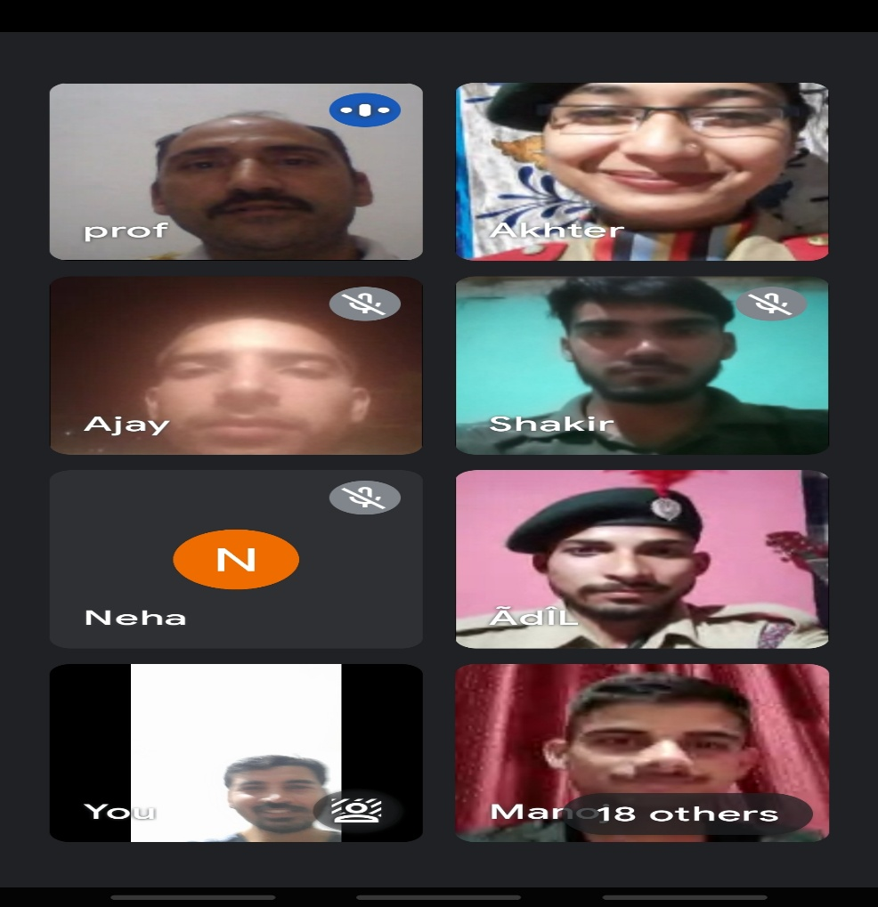
Webinar on “Respecting Elders”

National Webinar on Basics of Capital Market Organised at GDC Bhaderwah

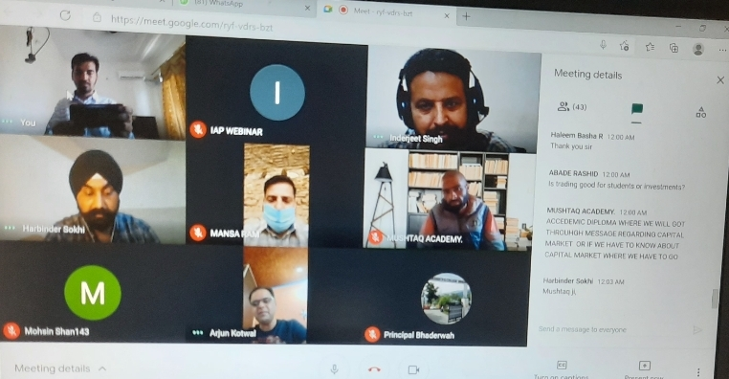
Career Counseling Cell and IQAC GDC Bhaderwah in collaboration with BSE and CSDL organised “ National Webinar on Basics of Capital Market”.The key speaker for the webinar was Mr Harbinder Singh Sokhi, Manager BSE .Making his power point presentation on the occasion Mr Sokhi in a very simplified and précised way explained the connect between the SEBI,Stock Market,Investors and Corporates. He focused different guiding principles for investment in the market and at the same time remaining vigilant .Preferable he advised to adopt the mutual fund route for the beginners. Next speaker on the occasion was Mr Inderjeet Singh, Regional Head,CSDL who jointly with Mr Sabzar Ahmed ,the Resource Person threw light on the role of CSDL in today’s ICT driven times .Mr Sabzar Ahmed in his presentation highlighted the importance of Trading ,Demat & Saving Accounts for investing in the capital markets. He also explained different facilities as e-locker ,SMS alerts and other online services provided by the depository participants(DPs), The audience including students ,staff, delegates and other guests from different institutions of the country appreciated the presentations and the presenters got wide applaud on the occasion. In the technical session the audience raised different queries which were responded by the experts.Dr K.K.Sharma,Principal of the College and Chief Guest for the day appreciated the views put forward by the experts and he underscored the need to organise such events to educate and aware the learners and the youngsters .He thanked the experts and the guests ,congratulated the organising committee of the college.He appreciated the efforts of the IQAC for working on improving quality parameters . Dr Sharma expressed his satisfaction and happiness on successful conclusion of the event .Earliar welcome address was presented by Prof S.S.Parihar,Convenor ,IQAC.He also acted as moderator for the event.The platform for the event was Google Meet. Prominent present on the occasion were Prof Devinder Kumar,Prof Mansa Kak,Prof B.P.Chohan,Prof Shamim Akhter,Prof Deepa ,Prof Shikha ,Mr Uttam Singh ,Mr Mushtaq among the others.The event ended with a vote of thanks proposed by Prof Arjun Kotwal ,HoD, Computer Science.

Intellectual Dialogue on NEP 2020,ABC & Resources Organized at GDC Bhaderwah:
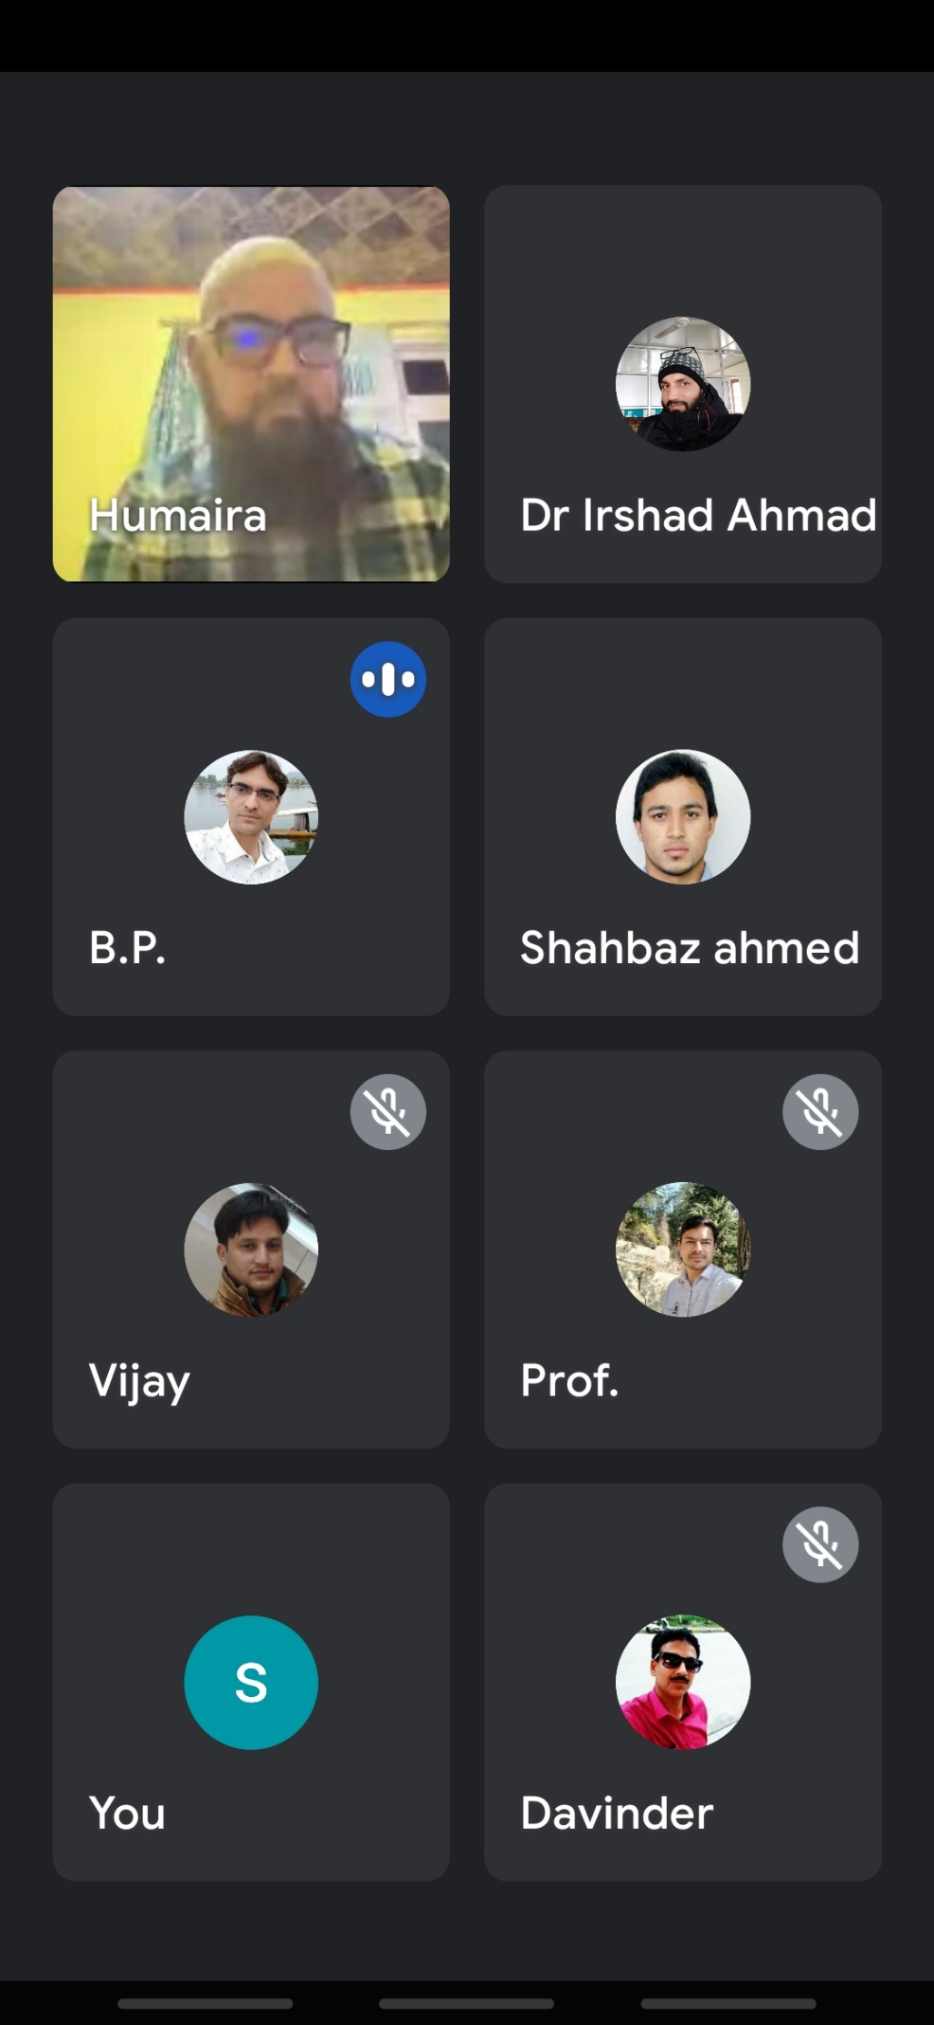
IQAC, GDC Bhaderwah organized an online Intellectual Dialogue on “NEP 2020, ABC & Resources :An Implementation Strategy under the aegis of Dr K.K.Sharma, Principal of the College & Chairman ,IQAC and as per directions of Higher Education Deptt, Govt of J and K.To start with Prof S.S.Parihar shared the structure of NEP 2020 with the staff members. Following this the dialogue started and in the interaction the teaching faculty deliberated on the crucial issues as Memorandum of Understanding, Lab facility, Class rooms, Staff position, syllabi/Modules,Intake capacity,Time table and Campus capabilities, University Affiliations and Acceptance, Skills and Industrial links,Placements,Traning,Current CBCS,Embedded Skills,Flexibility in curriculam,librarary services, Innovative and Incubation strategies, student support services in relevance with the New Education Policy 2020.Give the current infrastructure facility,staffing and financial position the Higher Education Institutes especially Degree colleges in the UT of Jammu and Kashmir are already suffering to implement the current UGC mandated Choice Based Credit System in toto.The department has initiated and introduced various new courses as food technology, Horticulture technology,Fine Arts and Music, Innovation and Incubation Centers ,Research Centers and other courses are in the pipeline. Though the efforts are in right directions ,yet the things are in infancy and road ahead is still not clear. This is because the ground reality is in total contrast to impliment the new strategies .Regarding the flexibility in the New Education Policy and managing Academic Bank of Credits got appreciations form the panel of experts and they call it in the interest of the learners.Yet the faculty suggested for further clarifications and the involvement of all the stakeholders.For better implimentation of NEP 2020,panel of experts based on Delphi Technique reached to following conclusions and submitted for:
1.Proper survey of the HEI,
2.Assessment of Physical, Financial and Human resources
3.Setting targets for the HEIs on short term basis as learning outcomes and long term as jobs/placement outcomes for implementation
4.Deciding priorities for allotment of courses to avoid the overlapping
5.Mandatory Industrial Academic linkages
6.Mandatory Placement Drives
7.Ensuring Accountability and Responsibility
8.Time to Time Feedbacks and Meets
9.Listing Achievements
10.Rewarding the honest and the dedicated employees
11.Involvement of the all the stakeholders
12.Mandatory and timely affiliations of courses by the concerned Universities
13.Staff welfare measures
14.Head of the HEIs to expedite and act to ensure progressive growth of the Institution.
15.Student support services Provision and other basic facilities
The staff members who contributed their valuable inputs during the discussion Prof Naz Zarger,HOD English, Dr Irshad Ahmed ,Prof B.P.Chauhan,,Prof Vijay Kumar,Prof Shahbaz Ahmed, HOD Electronics,Prof Davinder Kumar,HoD Botany. Prominent present on the occasion were Prof Rahul Uttam, HOD Mathematics, Dr Reyaz Ahmed, HOD Arabic, Dr Javed Ahmed , HOD Urdu and Prof Manzoor Ahmed among the others. The dialogue ended with a vote of thanks proposed by Prof S.S.Parihar ,the host for the live interactive session.

5 Days Event on the occasion of International Day Against Drugs Addiction and Illicit Trafficking concludes at GDC Bhaderwah :

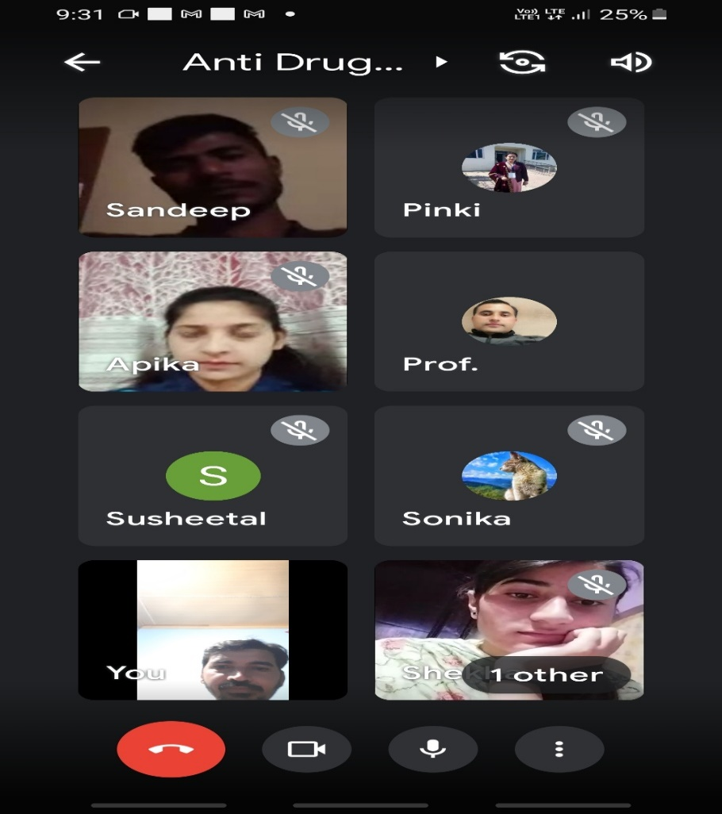
NSS, NCC and IQAC, GDC Bhaderwah conjointly organized an online 5 days long event on the occasion of International Day Against Drugs Addiction and Illicit Trafficking under the aegis of Dr K.K.Sharma, Principal of the College & Chairman ,IQAC .The theme for the event was Share facts on Drugs ,Save Lives. As per the event schedule from 22-26 June 2021 the students worked on the theme through posters,audio-video clippings,essay writings and creating short messages to spread the awareness on this serious menace. On the last day of the event live interaction was organised through Google Meet where the students and the staff members presented their ideas. To start with Prof S.S.Parihar ,Convener IQAC presented the welcome address . Following this the student speakers Mr Sandeep and Miss Pooja presented papers on the theme and nicely expressed their ideas nicely. The resource person for the live session was Prof Bal Krishan who in his presentation thoroughly presented the facts on drugs ,addiction,causes,possible solutions, managing teenage behavior .Like a professional speaker he delivered his words excellently and proficiently in a simplified way he highlighted as how the dopamine is made by the body ,used by the nervous system as a chemical messenger and its role in how we feel pleasure.
The prominent staff members present on the occasion were Dr Sandeep Kotwal,Prof Pinky Kotwal and Prof Prithvi Raj among the others .The event ended with a vote of thanks proposed by Miss Pooja Devi,student of 6th semester,GDC Bhaderwah.

Kabir Jayanti Celeberated with gaiety and Fervour at GDC Bhaderwah

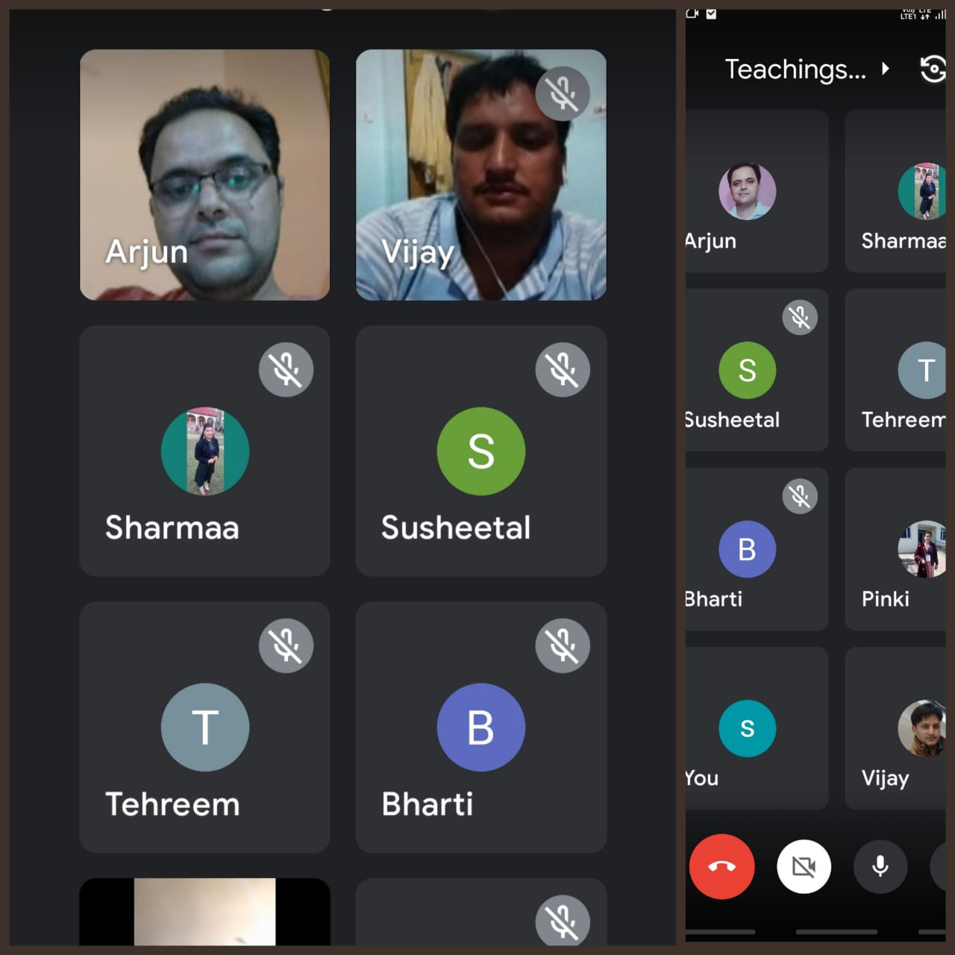
NSS, NCC and IQAC, GDC Bhaderwah conjointly organized an online on the occasion of International Kabir Jayantib .The eventvwas irganised under the aegis of Dr K.K.Sharma, Principal of the College & Chairman ,IQAC .The theme “Teachings of Saint Kabir”.Prof S.S.Parihar ,Convener IQAC presented the welcome address and acted as resource person on the occasion .In his presentation he highlighted how the transformation of lives is possible according to sipiritual lhilosophy preached by Bhakti Kal Saints like Sh Kabir.He explained the importance of Guru,initiation,Meditation in day today life.Explaining the Karma theory he said action is possibke by mind ,action and thoughtmAction are of three types current addition,Stored and the part of out of stored being faced.Without making karmic bakance zero,spiritual progress is not possible.Further fir spiritual progress being merciful and following non-violence is must.From this love and thirst take birth towards Godly affairs.Present on the occasion Prof Arjun Kotwal threw light on the biograghy of this great Saint and he related his philosophy to the current scenario. Prof Vijay Kumar recited Kabir Dohas(Couplets) and explained their indepth meaning in our lives.The prominent staff members and guests present on the occasion were Dr Omrajsingh from Udhampur,Prof Pinky Kotwal and Prof Varinder Kumar,Prof Deep Chand among the others .The event was organised throgh Google Meet and all the students and staff were invited to join the programne.The event ended with a vote of thanks proposed by Mr Vijay Kumar,Asstt.Prof Computer Science,,GDC Bhaderwah.

Villages Adopted:Kotli and Narnu Bhaderwah,Chinote,Nalthi

