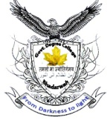**OFFICE OF THE PRINCIPAL**

**GOVT. DEGREE (PG) COLLEGE BHADERWAH (J&K)**

**(NAAC Accredited ‘B’ Grade Cycle-2)**

**E-mail : [principalgdcbhaderwah@gmail.com](mailto:principalgdcbhaderwah@gmail.com), Ph/Fax:01997244155/+919419910916, website: www.gdcbhaderwah.ac.in**

**\*\*\*\*\***

**Press Release**

**Govt. Degree (PG) College Bhaderwah organized multiple events on Cyber Awareness under Cyber Jaagrookta Diwas**

Under initiative of Govt. of India scheme Indian Cyber Crime Co-ordination Centre (14C) **Department of Computer Science GDC Bhaderwah in Collaboration with Cyber Jaagrookta Cell, NSS, NCC and Electoral Literacy cell** organized multiple events on Cyber Awareness under Cyber Jaagrookta Diwas today on 22nd September 2022 under the guidance of Dr. K. K. Sharma, Principal of the college. To start with the program Prof. Arjun Kotwal, HOD Computer Science Department GDC Bhaderwah and Nodal Officer Cyber Jagrookta Diwas presented the welcome address. The first event of the program was poster making. Many students of Computer Science Semester I presented there poster. The second event was speech on Cyber Crime. Many students of Computer Science Semester I spoke on the occasion. The third event was rally and market visit on Cyber awareness. The rally started from college with slogans related to Cyber crime and students also discussed about Cyber crime with the shopkeepers around the college. Staff members actively contributed in the program are Prof. S S Parihar, Prof. Prithvi Raj, Prof. Anuradha Sharma, Prof. Varinder Singh, Prof. Renuka Goria, Prof. Rahul Uttam, Prof. Shahbaz Ahmed, Prof. Ajay Singh and Prof. Shivani Padha along with Mr. Bhushan Kumar & Mr. Ashfaq Ahmed. The program ended with formal vote of thanks by Prof. Vijay Kumar of department of Computer Science.

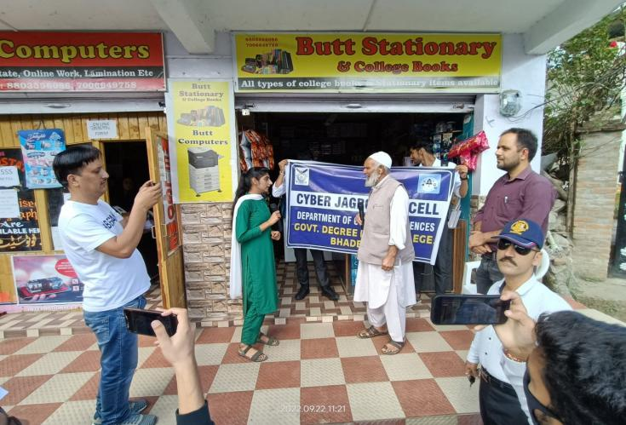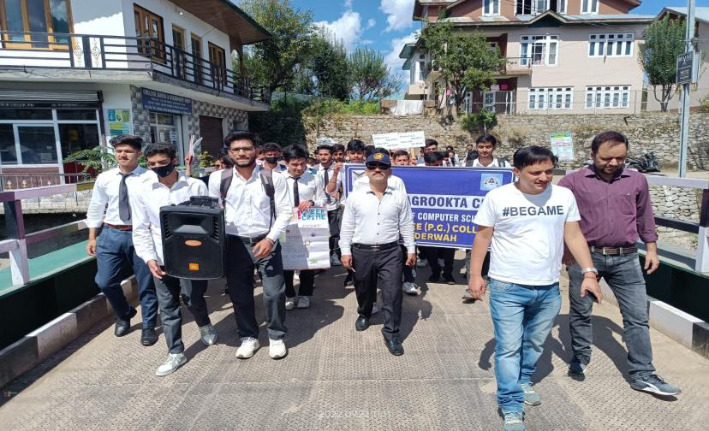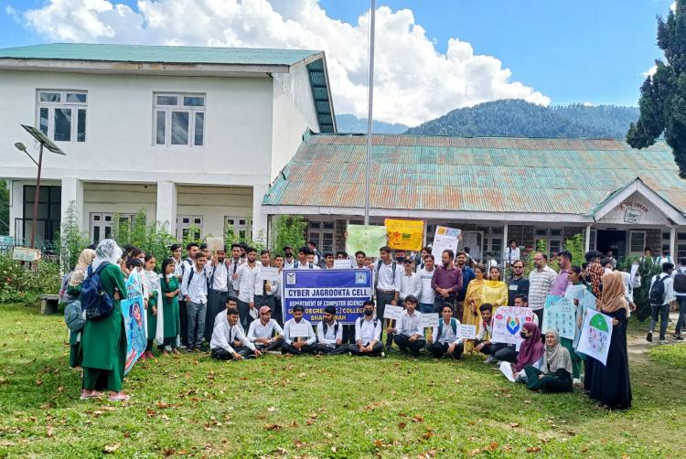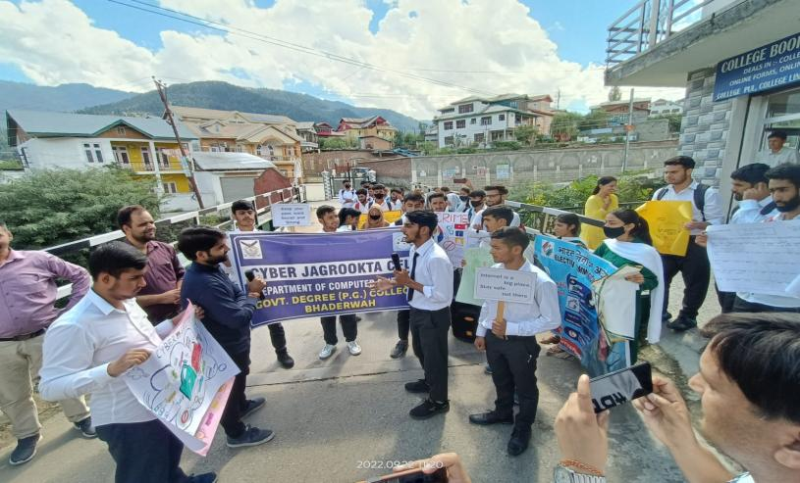

Principal

Govt. Degree College

Bhaderwah