Department of Environmental Sciences

Programmes conducted by the Department of Environmental Sciences, GDC Bhaderwah during the session 2019-2020

I. Department of Environmental Sciences conducted a field visit for the students of Semester III to Solid Waste Management Plant at Dranga, Bhaderwah on 18-10-2019.

Press Release
Department of Environmental Sciences, GDC Bhaderwah conducted one day field visit to Solid Waste Management Plant at Dranga, Bhaderwah
With an objective to impart practical knowledge to the students of Environmental Sciences (Sem III) related to Solid Waste Management (SWM), the Dept. of Environmental Sciences, GDC Bhaderwah organised one day field visit to SWM plant situated at Dranga, Bhaderwah on 18th of October, 2019. The visit was conducted under the overall guidance of Prof. Devinder Kumar, Principal, GDC Bhaderwah and under the supervision of Prof. Anuradha Sharma, HOD, Dept. of Environmental Sciences.
On the site of Solid Waste Management Plant, Sh. Surinder (Incharge, SWM plant) explained to the students about the entire management of the unit. The students were briefed about the overall process of collection, segregation and treatment of Solid Waste generated from Bhaderwah town. He explained how biodegradable waste (organic matter) gets segregated from the mixed waste and is processed into vermicompost which can be utilized as a fertilizer in the agricultural fields. He demonstrated the entire process how organic waste is firstly mixed with cowdung which after 15 days is introduced with earthworms that transforms it into useful manure (vermicompost) in about 90 days.
He also deliberated on various aspects of solid waste management and the new future interventions of plastic waste management to be taken up shortly by Bhaderwah Municipal Committee. He also motivated the students by actively contributing towards the reduction of solid waste production and segregation of Solid waste at the source level.
Overall, this field visit was a great learning experience wherein the students gained firsthand knowledge of what they have been learning theoretically.

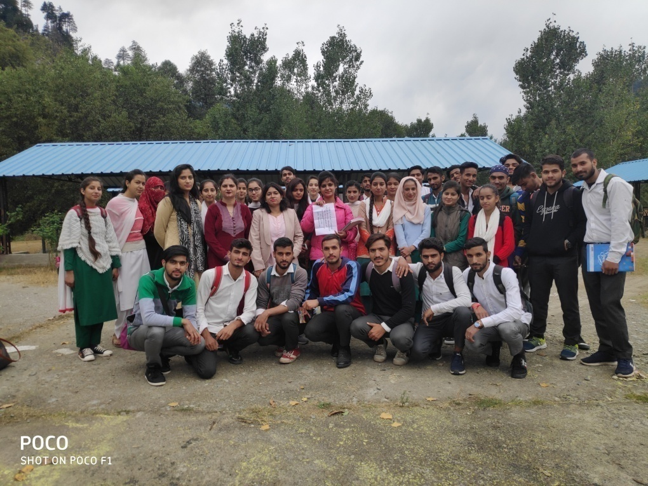

Sd/
Prof. Anuradha Sharma
Head, Dept. of Environmental Sciences
GDC, Bhaderwah

II. Department of Environmental Sciences conducted an Industrial Visit for the students of Semester V to Industrial Estate, Udhampur on 19-10-2019.

Press Release

GDC Bhaderwah conducts an Industrial Visit for the students of Environmental Sciences to Industrial Centre, Udhampur

One day Industrial visit was conducted by the Department of Environmental Sciences, GDC Bhaderwahfor the students of UG Sem V of Environmental Sciences to Industrial Centre at Battal Ballian, Udhampur on 19th Oct, 2019.The visit was organized under the stewardship of Prof. Anuradha Sharma (HOD, Dept. of Environmental Sciences) and Dr. Anu Sharma (Lecturer in Environmental Sciences). Other faculty members, Ms. Diksha (Lecturer in Chemistry) and Sh. Ajay Singh (Lecturer in Computer Sciences) also accompanied the visit. Around 53 students of UG Sem V of Environmental Sciences took part in this visit.

The visit commenced with the flagging off by Prof.Devinder Kumar (Principal,GDC Bhaderwah) and Prof. Surinder Singh (HOD, Deptt. of Economics). The visit was efficiently managed and coordinated by Sh. Sartaj Singh (Industrial Promotion Officer, DIC Udhampur) who wasspecificallydeputed by Sh. Suram Chand Sharma (General Manager, District Industries CentreUdhampur) for this purpose.

The students and accompanied staff members visited two different industries at Industrial Complex, Battal Ballian Udhampur and were shownto various industrial operations, sophisticated equipments, pollution control devices and working of Effluent treatment plant.

Firstly, they visited Dhanuka Agritech Limited, where Sh. S. S. Sobani (General Manager) andSh. Amit Dubey (Head, Human Resource) welcomed the students and staff of the college. They were thentaken to Effluent Treatment Plant (ETP) accompanied by one staff person,who also briefed the students about how the waste water generated from the plant is treated in ETP and the details of the various kinds of Pesticides and Growth Promoters produced by the industry. The students also witnessed the laboratory set up in the industrial unit for analytical purpose.
Later, the students were taken to Uma Cement Industrieswhere Sh. Mohit Agarwal (General Manager) apprised the students about the whole process of manufacturing and production of cement in a step-wise manner and the kinds of pollutants most prevalently released in cement industry. He also discussed various control devices being installedat Cements Industries. The students were exposed tothe practical Knowledge and first-hand experience regarding functioning ofbag filters, cyclones, wet scrubbers and many others such devices which were underuse in this industry.
Lastly, theofficials of DIC Udhampur,managers and the entire management team of industries were thanked and honoured by a token of gratitude and appreciation by Prof. Anuradha Sharma (HOD, Deptt. of Environmental Sciences)for the smooth conduct of this visit. To sum up, this industrial visit was a great learning experience wherein the students gained real time knowledge of what they have been learning theoretically.

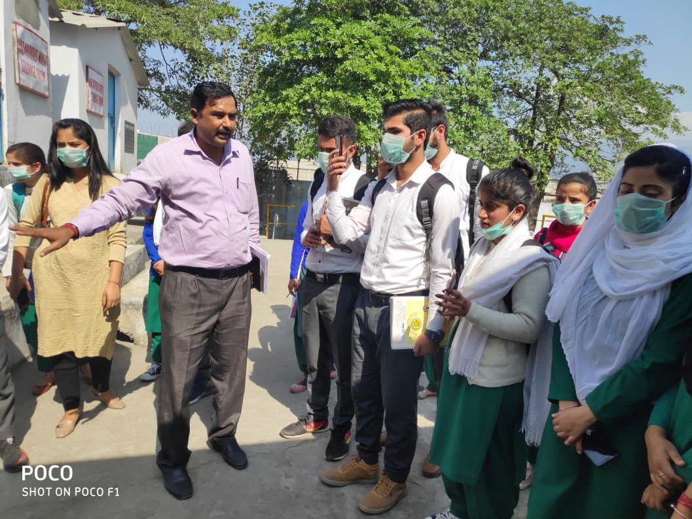

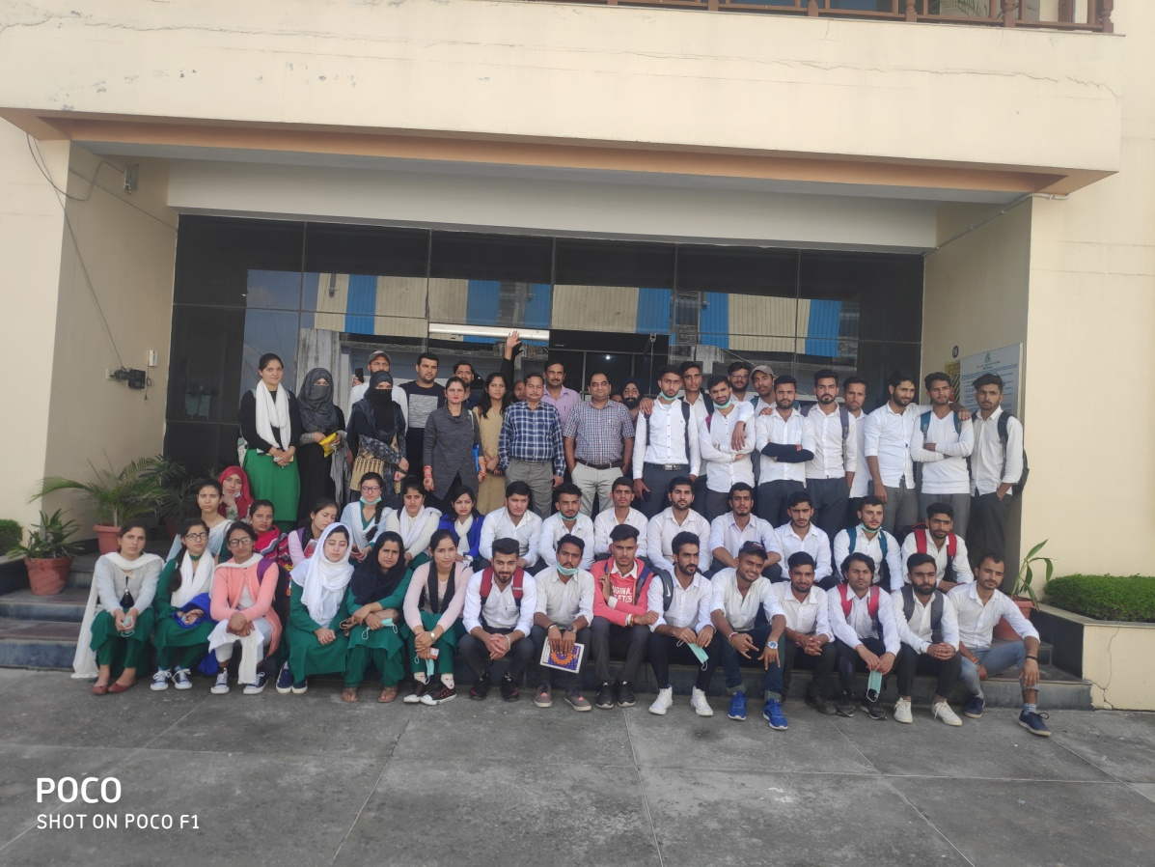
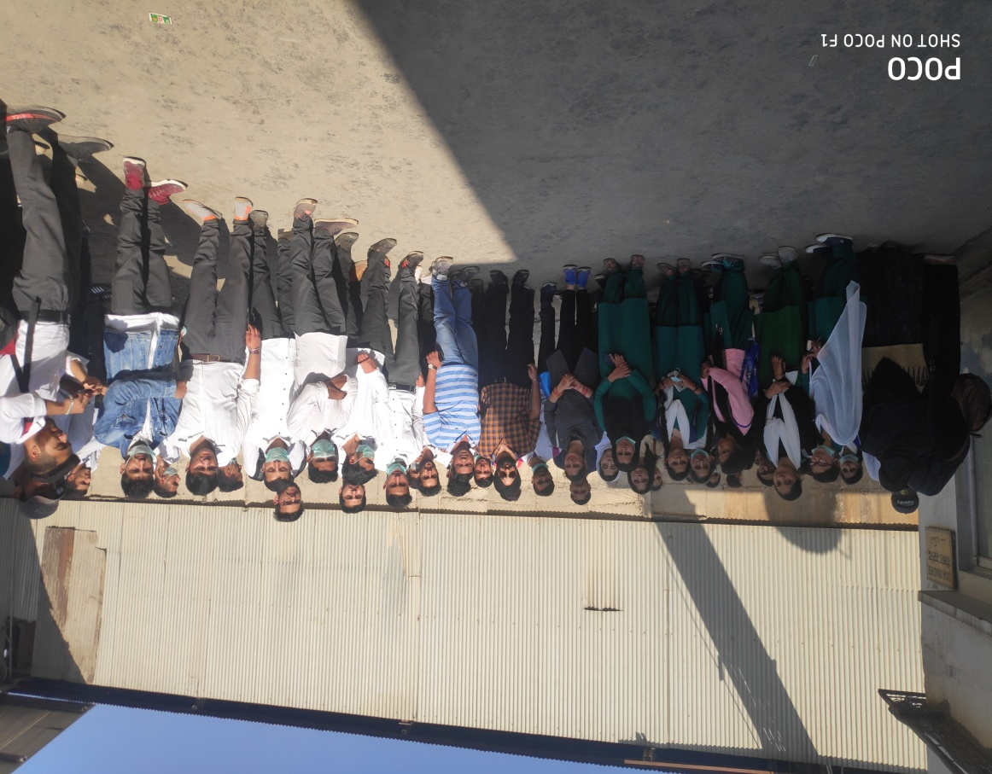

Sd/
Prof. Anuradha Sharma
Head, Department of Environmental Sciences
GDC, Bhaderwah

III. Department of Environmental Sciences organised a National level Online Contest on the theme “Celebrate Biodiversity” to celebrate World Environment Day on 5th June, 2020.

Press Release

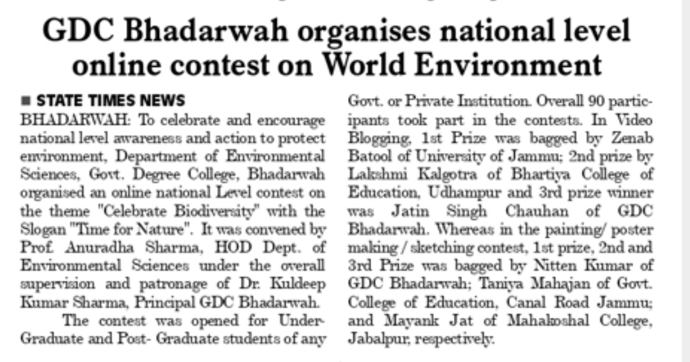

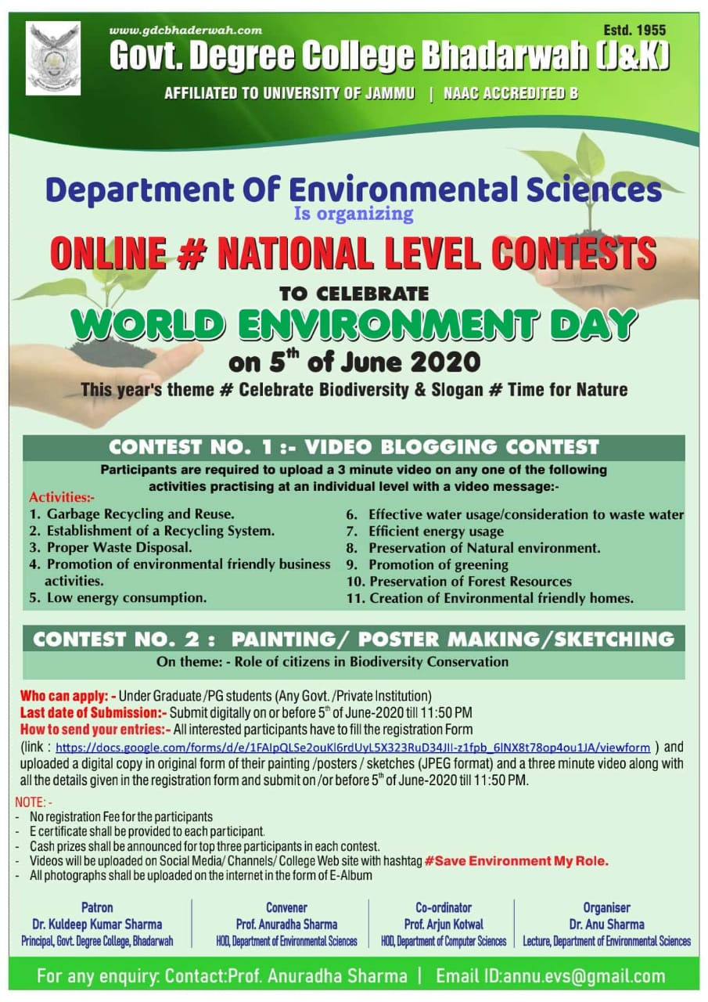

Sd/
Prof. Anuradha Sharma
Head, Department of Environmental Sciences
GDC, Bhaderwah
Programmes conducted by the Department of Environmental Sciences, GDC Bhaderwah during the session 2020-2021.

I. Department of Environmental Sciences conducted a field visit for the students of Semester III to Solid waste Management Plant at Dranga, Bhaderwah on 10-03-2021.

Press Release

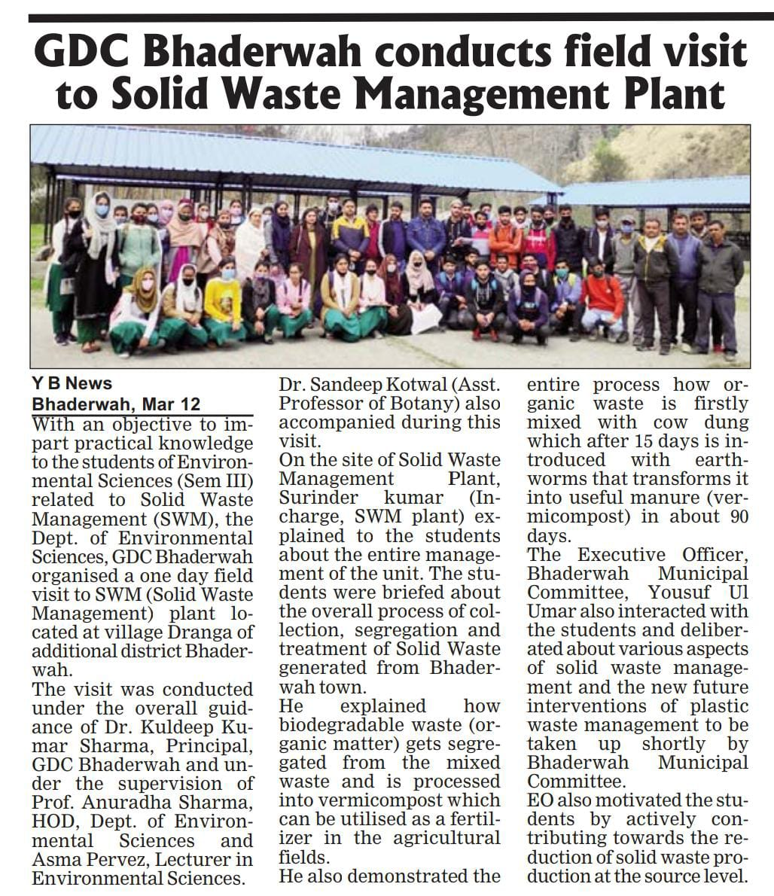

Sd/
Prof. Anuradha Sharma
Head, Department of Environmental Sciences
GDC, Bhaderwah

II. Department of Environmental Sciences and Department of Botany jointly organised One Day Plantation Drive cum Workshop in Collaboration with Forest Department, Bhaderwah on the theme “Forest Restoration: A Path to Recovery and Well-being” on 9th April, 2021.

PRESS RELEASE
GDC Bhaderwah organized One Day Plantation Drive cum Workshop
Department of Environmental Sciences and Department of Botany, Govt. Degree College Bhadarwah organized one day Plantation Drive cum Workshop in collaboration with Forest Department, Bhadarwah on the theme “Forest Restoration: A path to recovery and well being”. The event was organized under the visionary guidance of Principal of the college Dr. Kuldeep Kumar Sharma, Head Department of Botany, Prof. Davinder Kumar and Head Department of Environmental Sciences, Prof. Anuradha Sharma whereas DFO Bhadarwah Sh. Chander Shekhar was the chief guest on this occasion. The programme started off with sowing of seed balls of Cedrus, Pinus and other species in the degraded slopy hills of nearby Rainda Village, Bhadarwah followed by planting of saplings of Cedrus and Pinus species in the college premises by DFO Bhadarwah, DySp Bhadarwah (Sh Meer Gufoor), Principal, Staff members and students of the college. The cadets of NCC and NSS, GDC Bhadarwah also actively participated in the programme. Formally, the event was inaugurated by lighting of the ceremonial lamp by the dignitaries. The whole event was organised to commemorate 75th year of Independence- Azadi Ka Amrut Mahotsav.
On this occasion a formal welcome address was presented by Principal of the college Dr. K. K. Sharma and during his address he focused on the role of forests in environment protection. He also asserted that such events in educational institutions will go a long way in sensitizing the masses as students are the best ambassadors to spread awareness messages in the society. On this occasion a symposium and a poster making competition were also held on the same theme in which large number of college students actively participated. Prof. B.P Singh, Dr. Wahied K Balwan and Prof. Sandesh Kumar were the members of jury. Based on the judgement of jury, Haseena Banoo, Mushied Hussain and Divya Rathore all students of UG Semester Vth were adjudged as 1st, 2nd and 3rd respectively in poster making competition.
During his address on this occasion DFO Bhaderwah, Sh. Chander Shekhar dealt at length on the importance of forests in purification of environment and its role in survival of living organisms. He emphasized for planting more and more trees to make the environment clean and green and a better place to live. Prominent among others who were present on this occasion include Prof. N.K Manhas, Prof. Sanjay Katal, Prof Prithvi Raj, Prof. Pinki Kotwal, Prof. Arjun Kotwal, Prof. Vijay Kumar, Prof. Ashwani Kumar, Prof. Manjeet Charak, Prof Ankush Kumar, Prof. Riyaz Ahmed, Prof. Irshad Wani, Dr. Sanjay Kumar, Prof. Shahbaz Ahmed, Prof. Nazar-ul-Islam, Prof Asma Pervez, Dr Sangeeta Kumari and Dr Shahroora.
The formal vote of thanks was presented by Dr. Sandeep Kotwal of Department of Botany whereas Dr. Anu Sharma of Department of Environmental Sciences conducted proceedings of the programme.

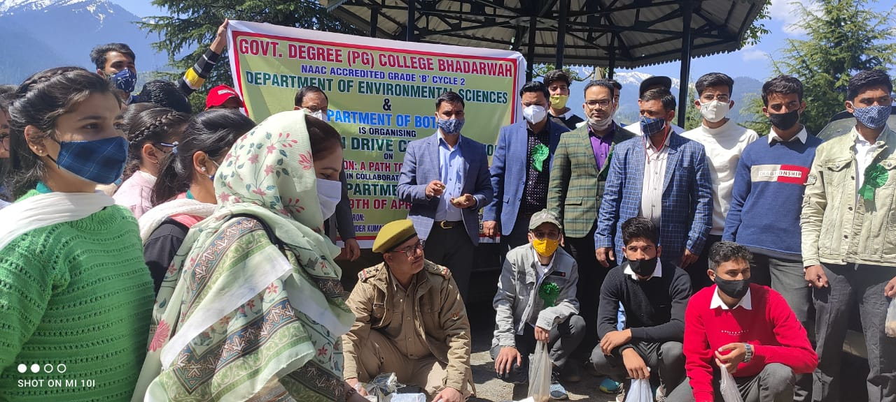

Sd/-
Prof. Anuradha Sharma
Head, Department of Environmental Sciences
GDC Bhaderwah

III. Department of Environmental Sciences organised an Online Dialogue on the theme “Ecosystem Restoration” under the vision- Azadi Ka Amrut Mahotsav to celebrate World Environment Day on 5th June, 2021.

Press Release
GDC Bhaderwah organizes Online Dialogue to celebrate World Environment Day, 2021
To mark the importance of Nature and Environment to us, Department of Environmental Sciences, GDC Bhaderwah organized One day Online Dialogue on the theme ‘Ecosystem Restoration’ to celebrate World Environment Day on 5th of June, 2021 The Programme was organized under the patronage of Dr. Kuldeep Kumar Sharma, Principal, GDC Bhaderwah and Convenership of Prof. Anuradha Sharma, Head, Department of Environmental Sciences on Google meet platform.
The Programme kickstarted with the Welcome Address of Principal GDC Bhaderwah, Dr. Kuldeep Kumar Sharma in which he welcomed the Chief Guest of the occasion Sh. Satpaul Pakhru (IFS), Conservator of forest, Chenab Circle, J&K, Sh. Sandeep Kumar (IFS), Divisional Forest Officer, Tarai (UK) as Guest of Honour, Sh. Maraj-ud-Din Malik (I/C DCF), Regional Director, Social Forestry, Kashmir as Special Invitee and Sh. Chander Shekhar (SFS), Divisional Forest Officer, Bhaderwah, J&K as speaker of the Programme. He highlighted the current global environmental issues and what small individual efforts should be taken to restore the Ecosystem and protect the Environment.
Sh. Satpaul Pakhru, Conservator of forest, Chenab Circle, J&K, in his opening remarks gave a brief account on various threats to ecosystems by anthropogenic activities especially the developmental projects and the different interventions being done by the forest Department for Eco-Restoration of Forests and to make the better environment. Sh. Chander Shekhar, Divisional Forest Officer, Bhaderwah, J&K deliberated upon the impacts of climate change and what should be the plausible action be taken to restore the degraded ecosystems owing to human-induced interventions. Sh. Maraj-ud-Din Malik (I/C DCF), Regional Director, Social Forestry, Kashmir spoke at length on the conversion of Agricultural land to Horticultural land being done in Kashmir and this led to degradation of Ecosystem and also gave a brief and apt co-relation and analytical association between Agricultural practices and Eco-restoration. Sh. Sandeep Kumar (IFS), Divisional Forest Officer, Tarai (UK) gave a presentation on “Eco-Restoration of Alpine Meadows- A Case study of Dayara Bughyal (UK)” in which he discussed the practical approach that how he implemented the Eco-restoration Project of high altitude Pasture-land of Dayara Bughyal in Uttarakhand for which he awarded with Chief Minister(CM) Award 2020. The speakers also responded some of the queries proposed by the participants. Many Faculty Members of GDC Bhaderwah and other colleges across the Union Territory of J&K and Students participated in the programme.
The programme concluded with formal vote of thanks by Dr. Sandeep Kotwal, Sr. Assistant Professor of Botany who also acted as co-convener and Prof. Anuradha Sharma acted as Moderator of the Programme.

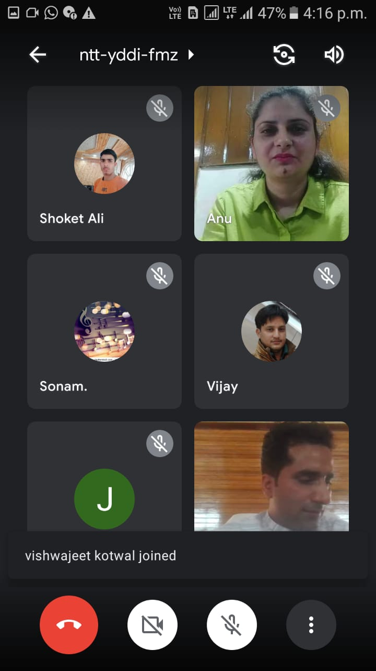

Sd/
Anuradha Sharma
Head, Dept. of Environmental Sciences

Programmes conducted by the Department of Environmental Sciences, GDC Bhaderwah during the session 2021-2022.

I Department of Environmental Sciences organized a Slogan Writing and Poster Making Competition to celebrate World Ozone Day 2021

Report

On the occasion of World Ozone Day, 2021 under the vision of Azadi Ka Amrit Mahotsav, the Department of Environmental Sciences, GDC Bhaderwah organized a Slogan Writing and Poster Making Competition for the Under-Graduate Students of Union-Territory of J&K on 16th September 2021 through virtual mode. The 2021 World Ozone Day theme is MONTREAL PROTOCAL- KEEPING US, OUR FOOD AND VACCINES COOL. The day marked to remind individuals, communities and Governments about the importance of ozone layer to our survival on Earth. In total, 127 students participated in the competition in which 3rd position was bagged by Kumari Bharti (Sem II), 2nd position was secured by Sofia Bano (Sem I) and Ist position was bagged by Adnan Bashir Bhat (Sem I) of GDC Bhaderwah. The students in top three positions were also issued e-certificates.
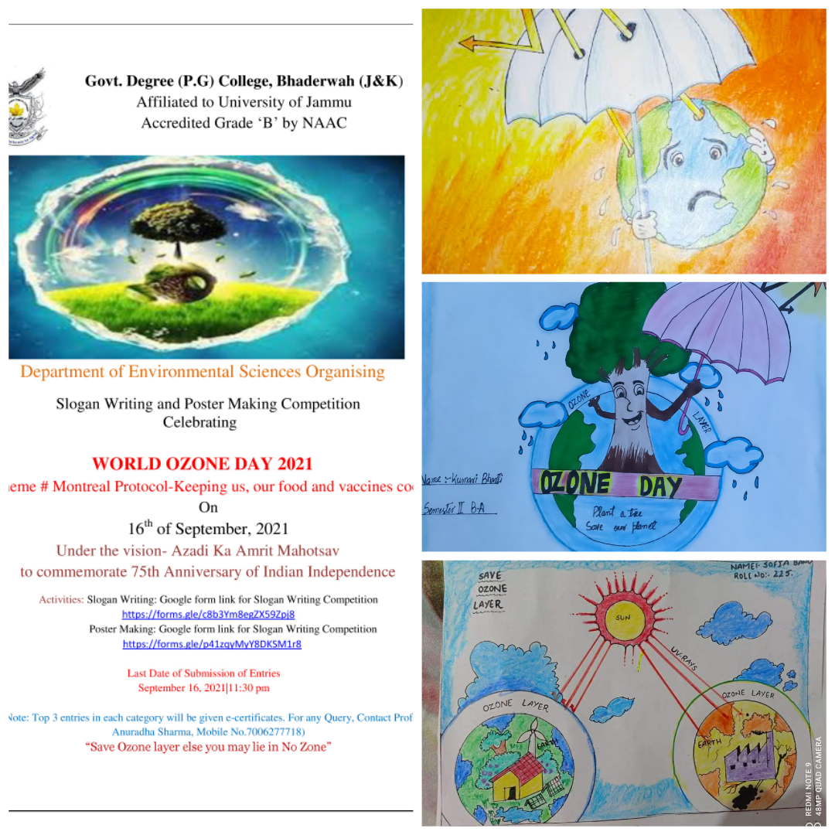
Sd/-
Prof. Anuradha Sharma
Head, Dept. of Environmental Sciences
GDC Bhaderwah
II. Department of Environmental Sciences organized Trekking cum Awareness Programme to celebrate International Mountain Day on 11 Dec, 2021.

Press Release

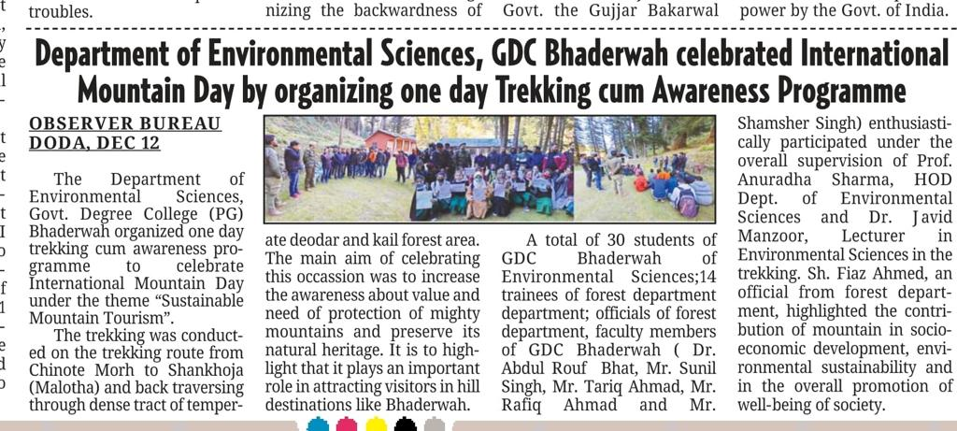

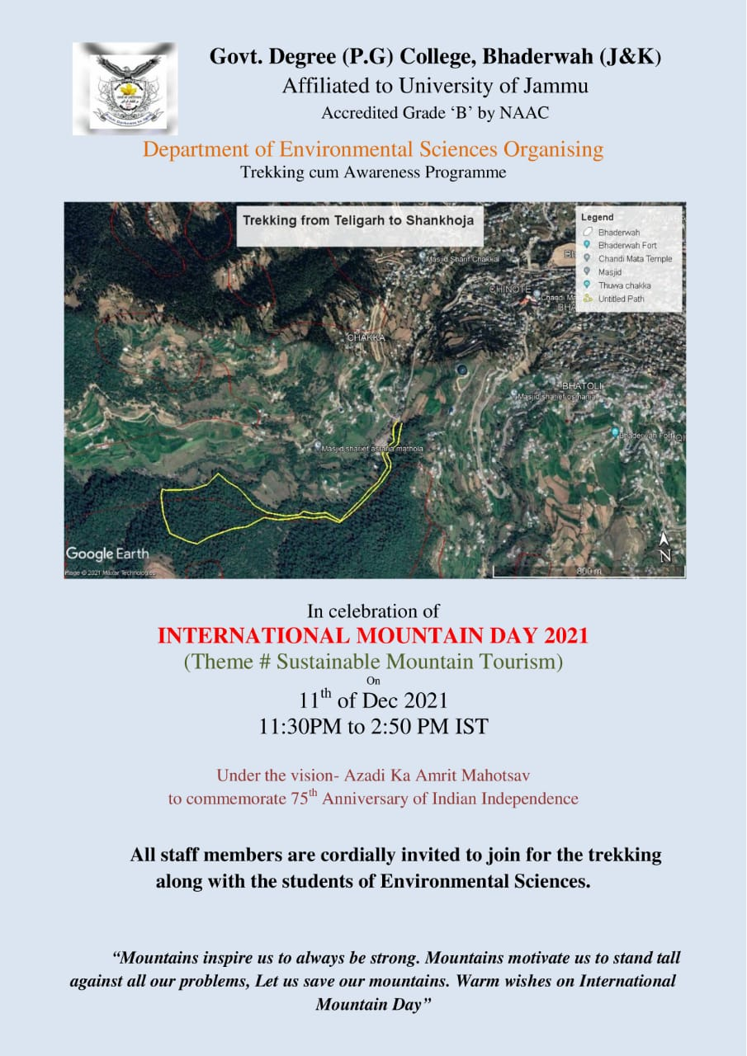

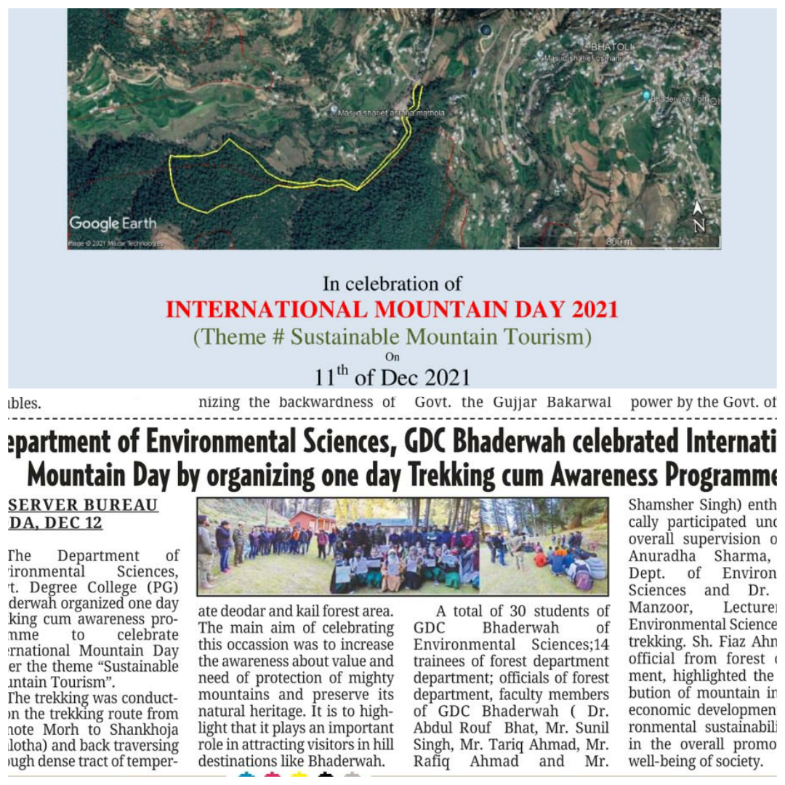

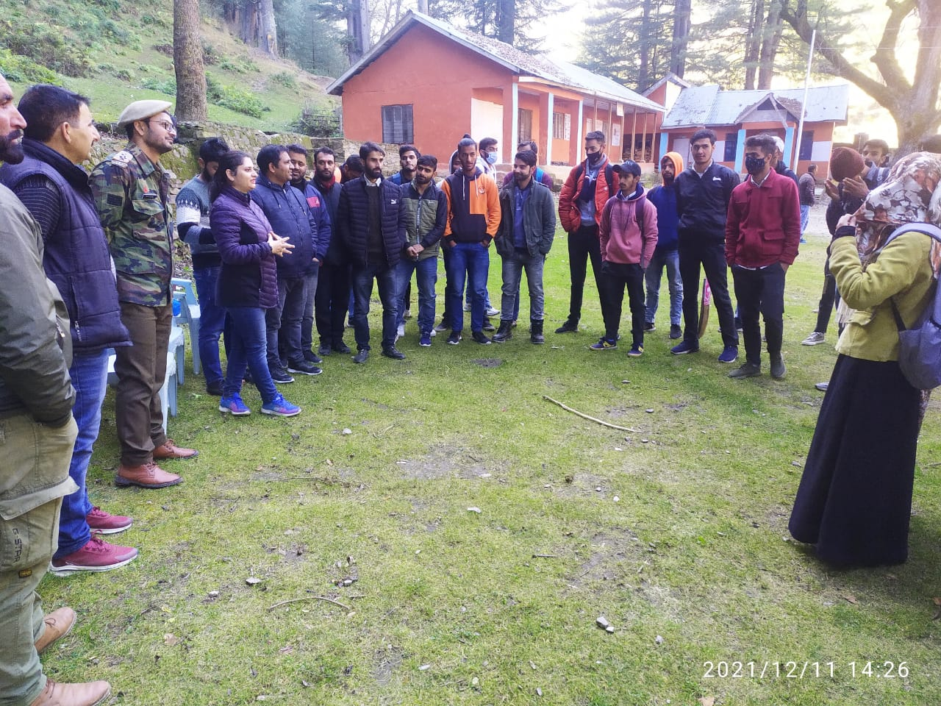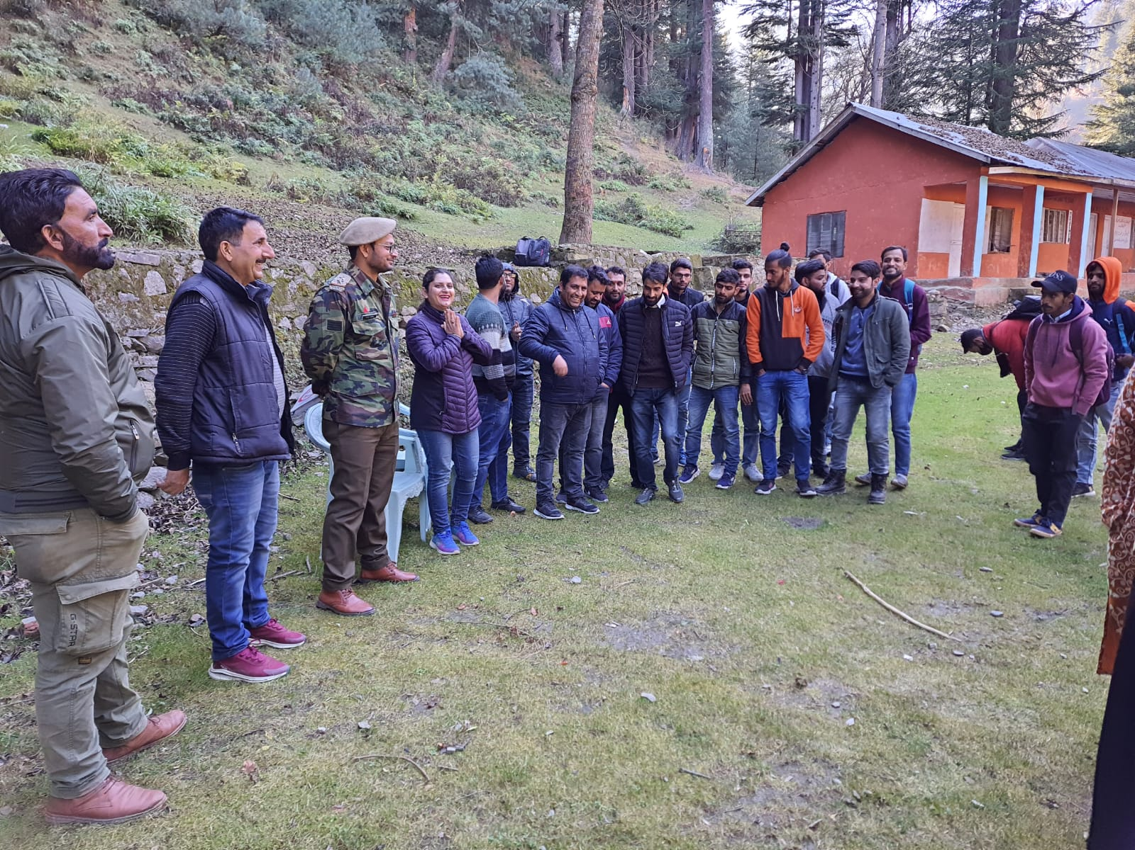

Sd/-
Prof. Anuradha Sharma
Head, Department of Environmental Sciences
GDC, Bhaderwah

III. Department of Environmental Sciences, GDC Bhaderwah conducted one day field visit to Solid Waste Management Plant at Dranga, Bhaderwah
Press Release

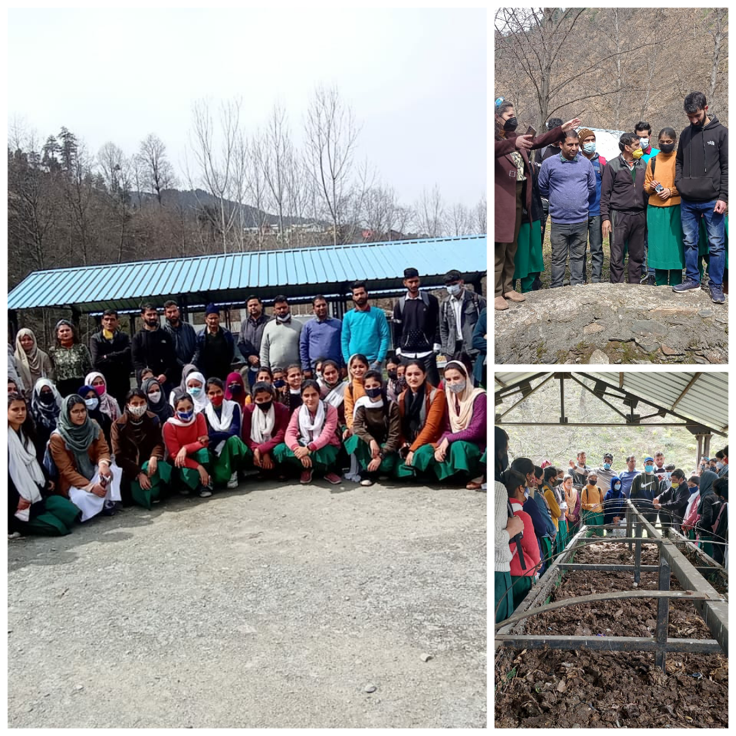

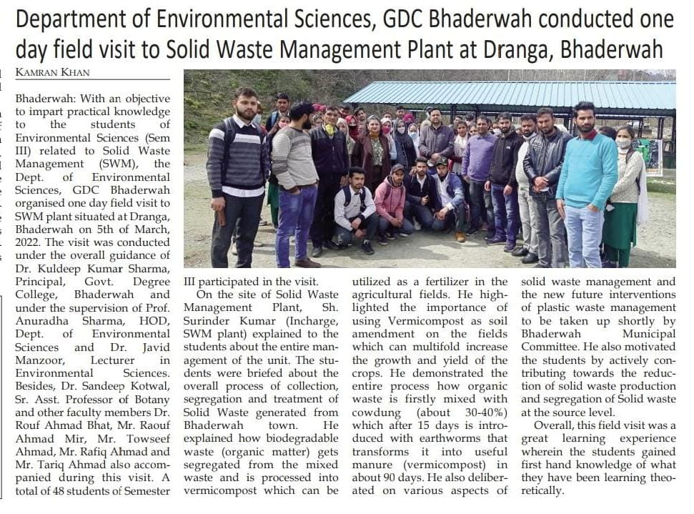

Sd/-
Prof. Anuradha Sharma
Head, Department of Environmental Sciences
GDC Bhaderwah

IV. Department of Environmental Sciences organised an Exhibition on “Best out of waste” and Rangoli Competition on the Theme “Reduce, Reuse and Recycle” to celebrate Global Recycling Day 2022.

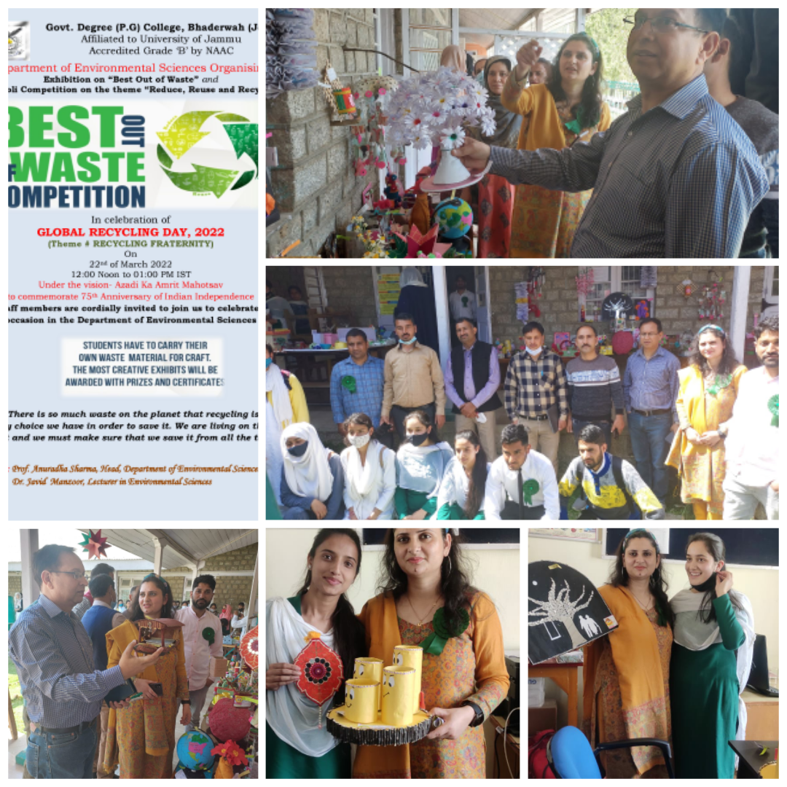

Report
With an aim to sensitize students about environmental conservation, natural resource management and to inculcated habit of waste minimisation, Department of Environmental Sciences conducted an Exhibition cum Rangoli Competition on the theme “Best out of Waste” to celebrate Global Recycling Day, 2022 under the vision Azadi Ka Amrut Mahotsav”. About 60 students of Sem III and V of Environmental Sciences took part in the competition and displayed their crafts/ work along with some nominal price tags which include articles of daily use or some decorative pieces made out of waste or discarded items generated in our homes and offices may it be paper, plastic, cardboard, glass, metals, ceramics etc. The whole programme was conducted under the supervision of Prof. Anuradha Sharma, Head, Department of Environmental Sciences and Prof. Javid Manzoor, Lecturer in Environmental Sciences and the guidance of Worthy Principal, GDC Bhaderwah Dr. Kuldeep Kumar Sharma who also applauded the sincere work and efforts put by all the students and organising team to make it happen successfully. He apprised the students that nothing is like the waste on this planet as the waste can be used as a resource to produce energy or fuel by adopting 3Rs: Reduce, Reuse and Recycle. Prof. Devinder Kumar, Head, Department of Botany and Prof. Mansa Ram, Head, Department of Zoology were reposed the responsibility to judge the competition.
About 60 students participated in Exhibition cum Rangoli Competition held outside the Department of Environmental Sciences. Many faculty members also came to witness various crafts/ work displayed in the exhibition and motivates the students to carry forward such kind of attitude of recycling waste throughout their lives. All the students were given the Certificate of participation in the event. This Exhibition cum Rangoli Competition assume significance in that it attempts to bring much needed awareness to the young generation and the community at large of the need to reuse recyclable materials in order to minimise environmental degradation.
`1Q++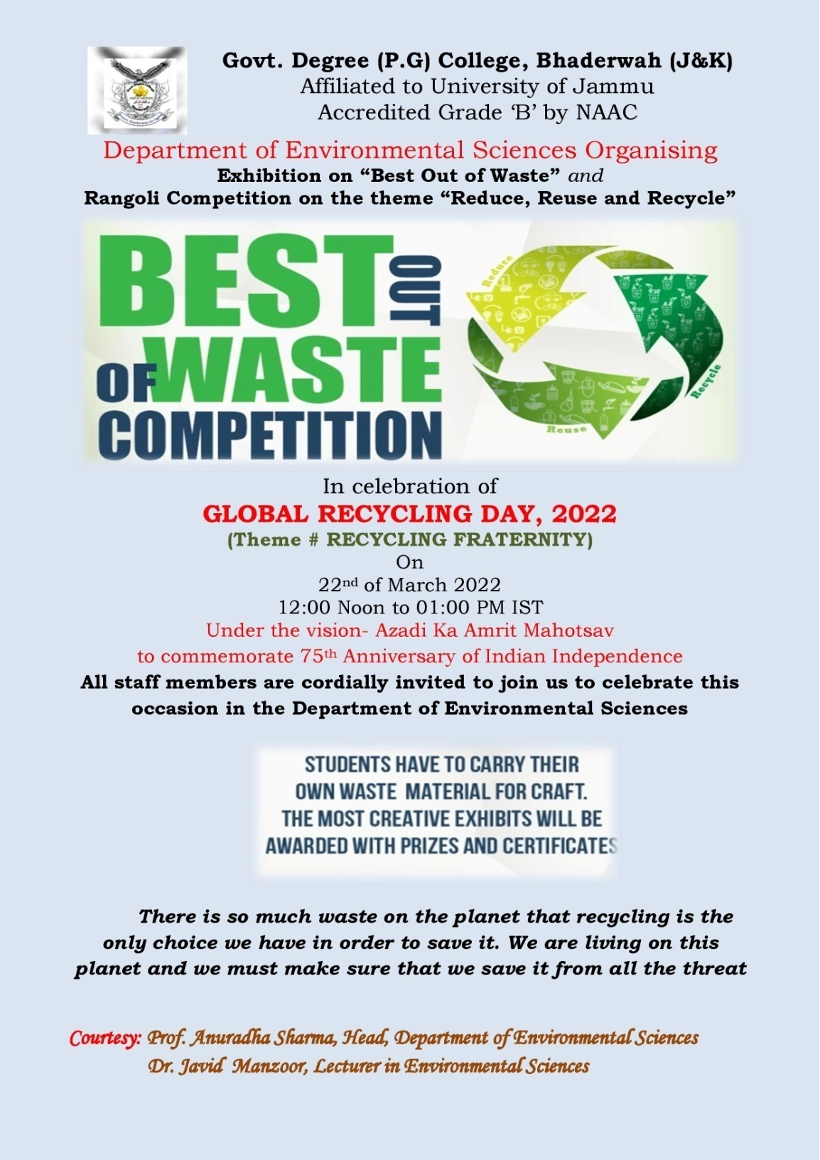

Sd/-
Prof. Anuradha Sharma
Head, Department of Environmental Sciences
GDC, Bhaderwah

V. Department of Environmental Sciences organised an Industrial Visit to Cedar Wood Oil Manufacturing Unit, M/S Natural Essential Oil at Industrial Estate, Dandi, Bhaderwah

Press Release

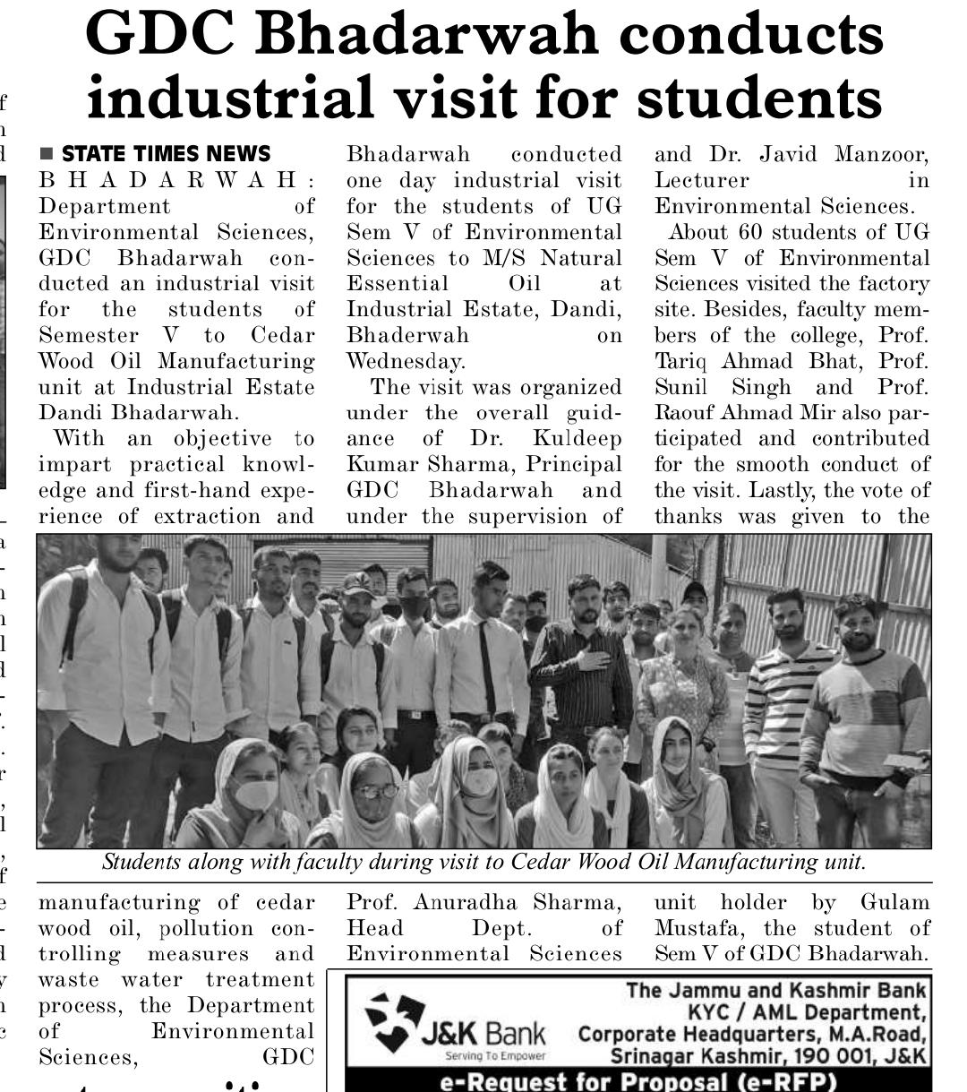

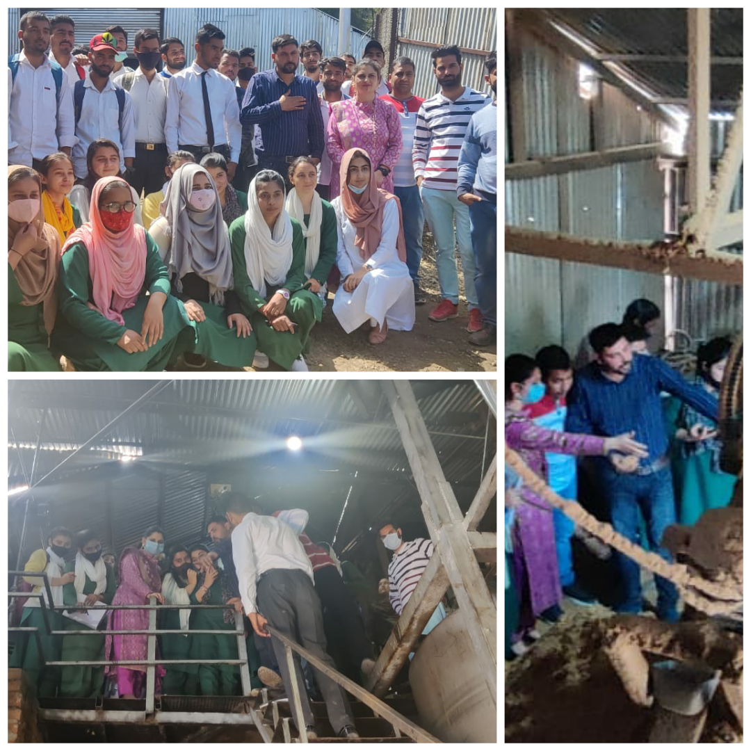

Sd/-
Prof. Anuradha Sharma
Head, Department of Environmental Sciences

VI. Quiz Competition was organised by the Department of Environmental Sciences in Collaboration with EcoClub on the topic “Environmental Pollution”

Press Release

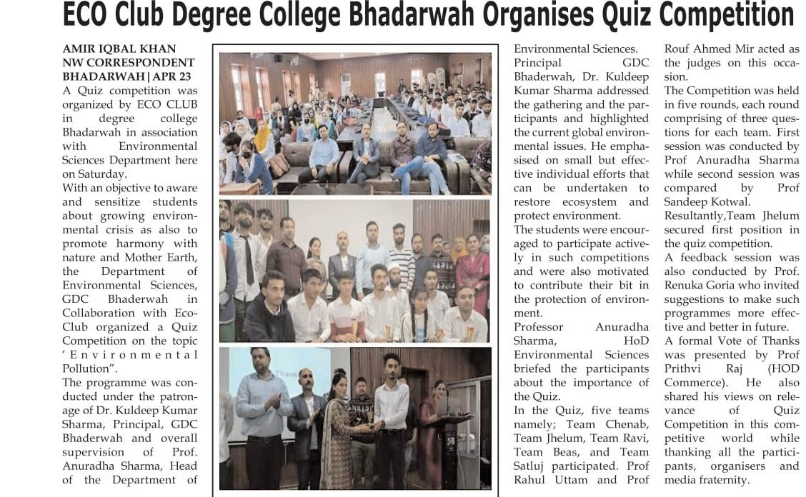

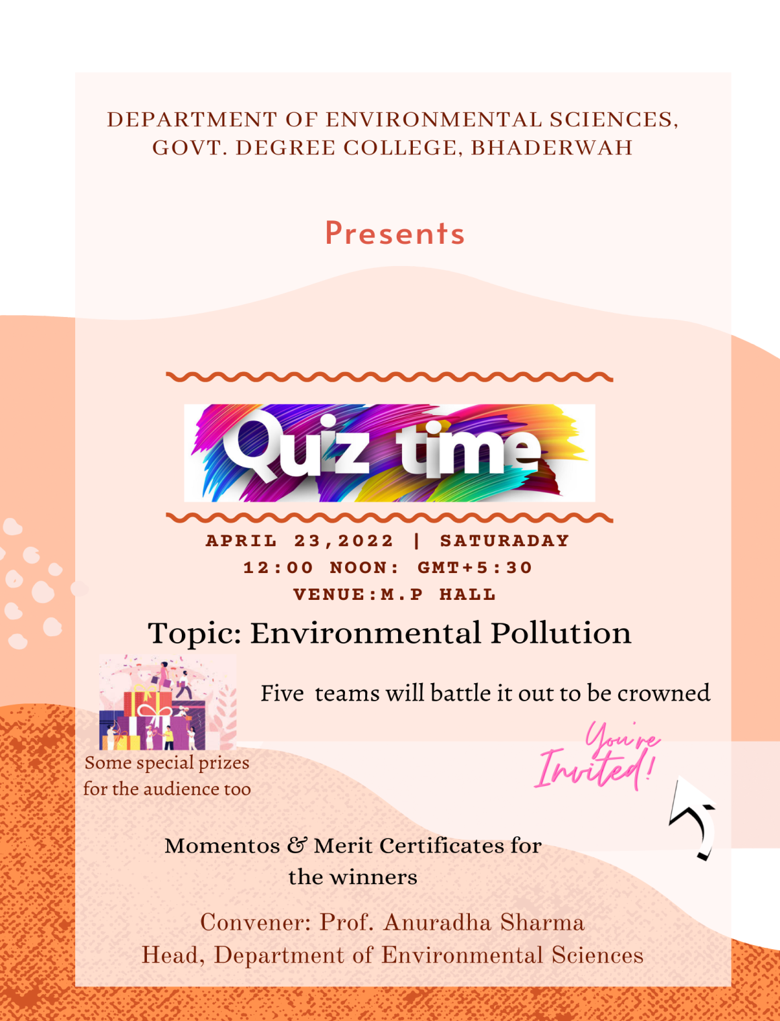
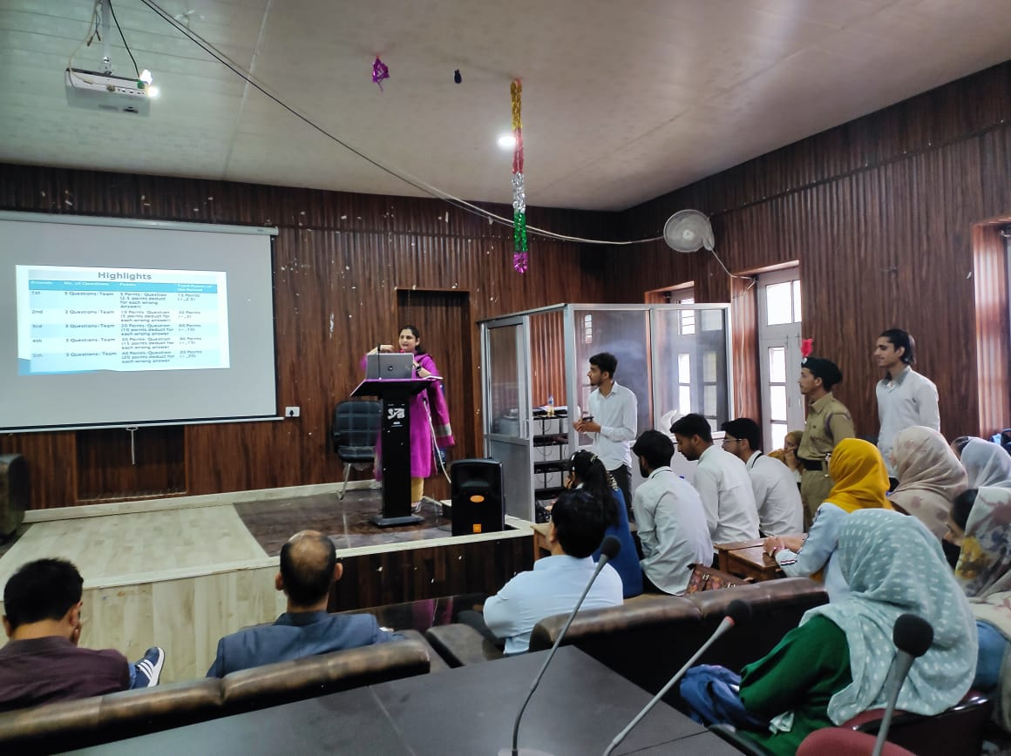

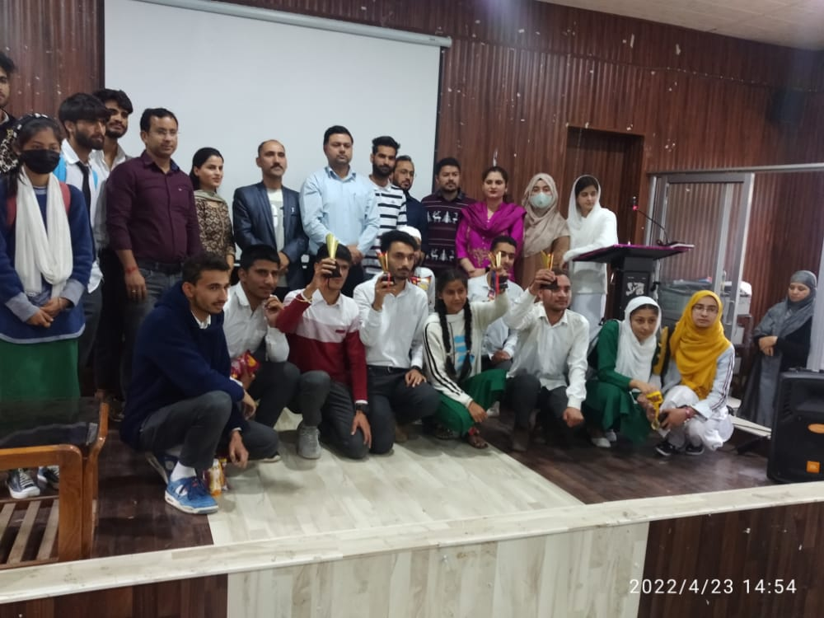

Sd/-
Prof. Anuradha Sharma
Head, Department of Environmental Sciences

VII. Department of Environmental Sciences organised a Webinar on the topic “Biodiversity of Chenab Basin” to commemorate International Biological Diversity 2022.

Press Release

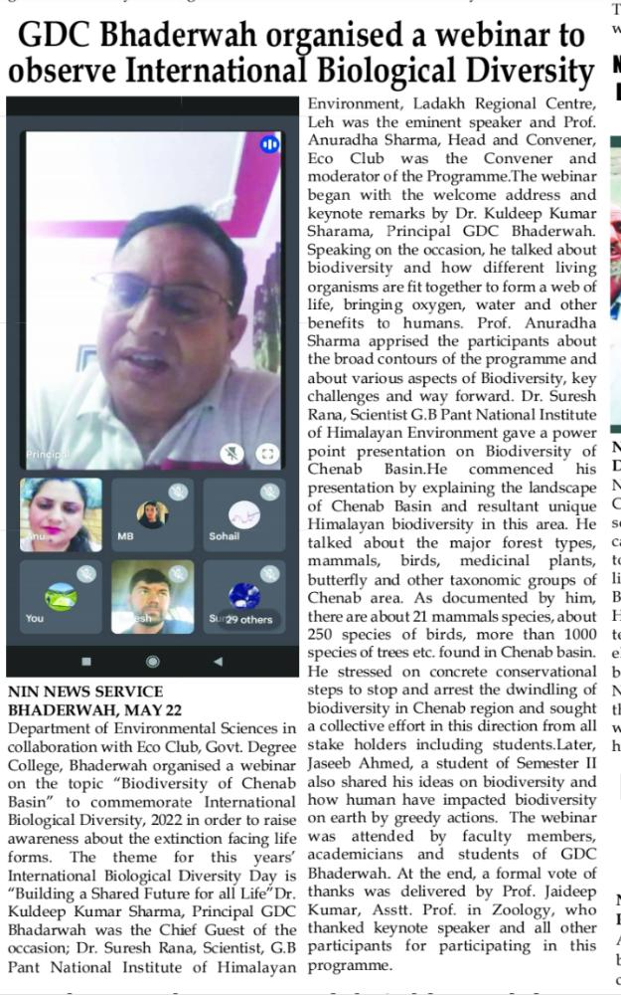

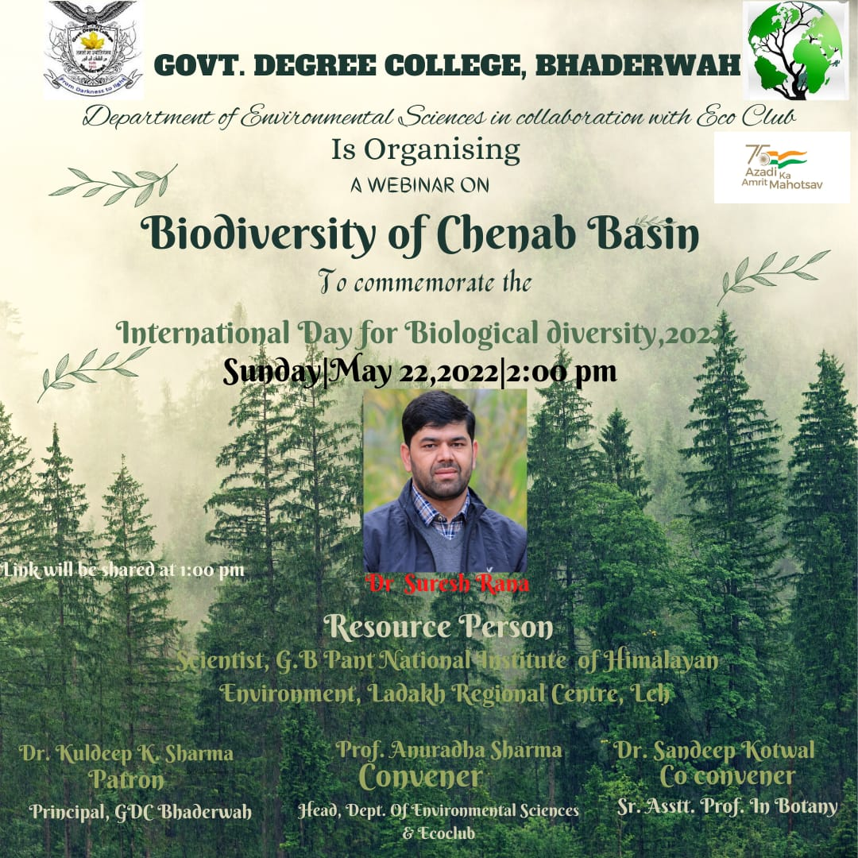

Sd/-
Prof. Anuradha Sharma
Head, Department of Environmental Sciences

VIII. Department of Environmental Sciences organised a Plantation Drive in Collaboration with JK Forest Department, Indian Army (4RR) and District Legal Service Authority (DLSA), Bhaderwah on the Occasion of World Environment Day, 2022.

Press Release
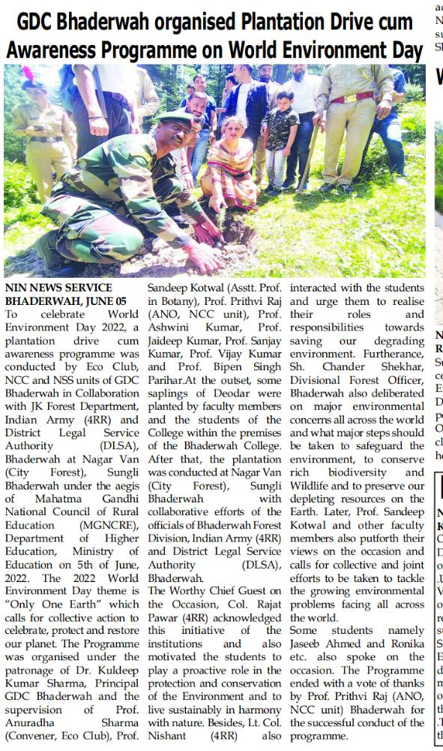

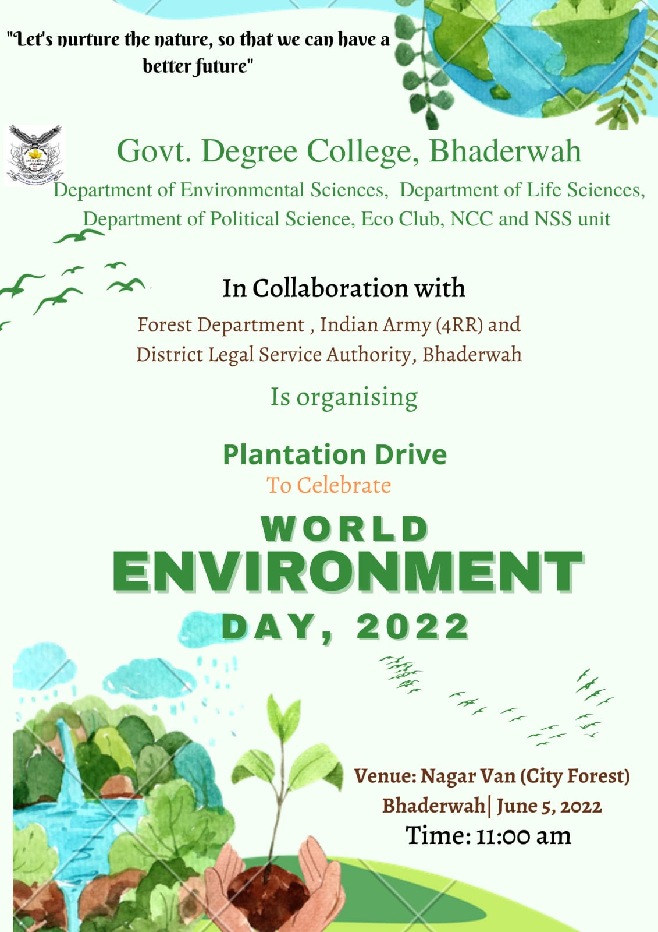
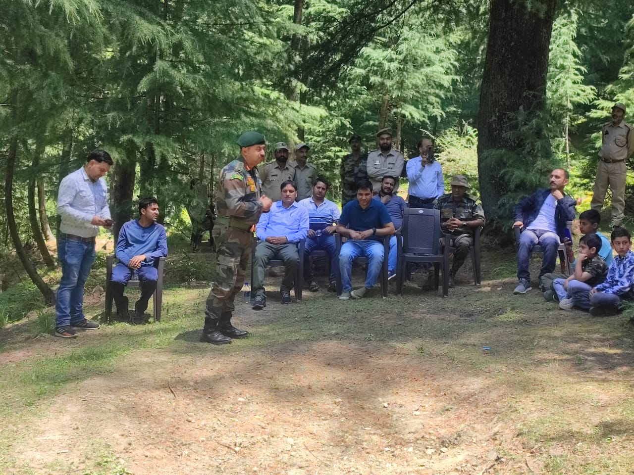

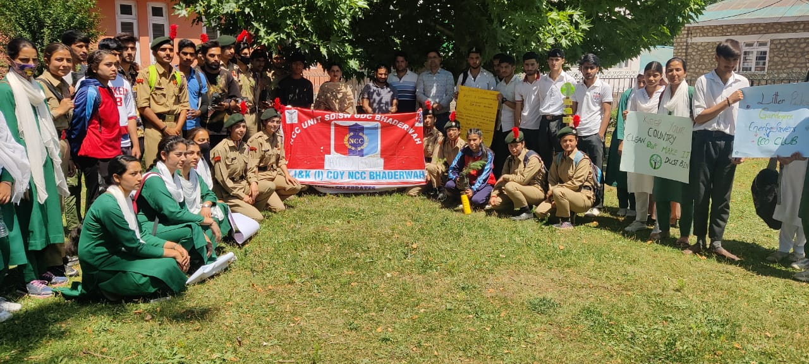

Sd/-
Prof. Anuradha Sharma
Head, Department of Environmental Sciences

X. Department of Environmental Sciences organised One Day Workshop cum training programme on Disaster Preparedness and Management in collaboration with State Disaster Response Force, Doda.

Press Release

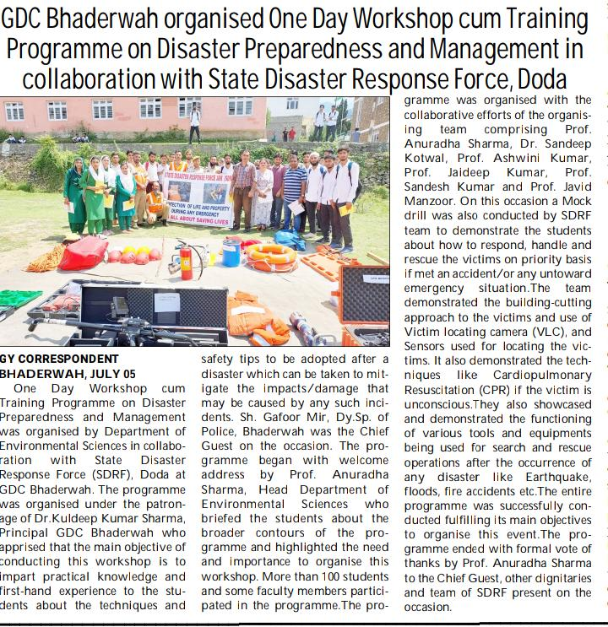

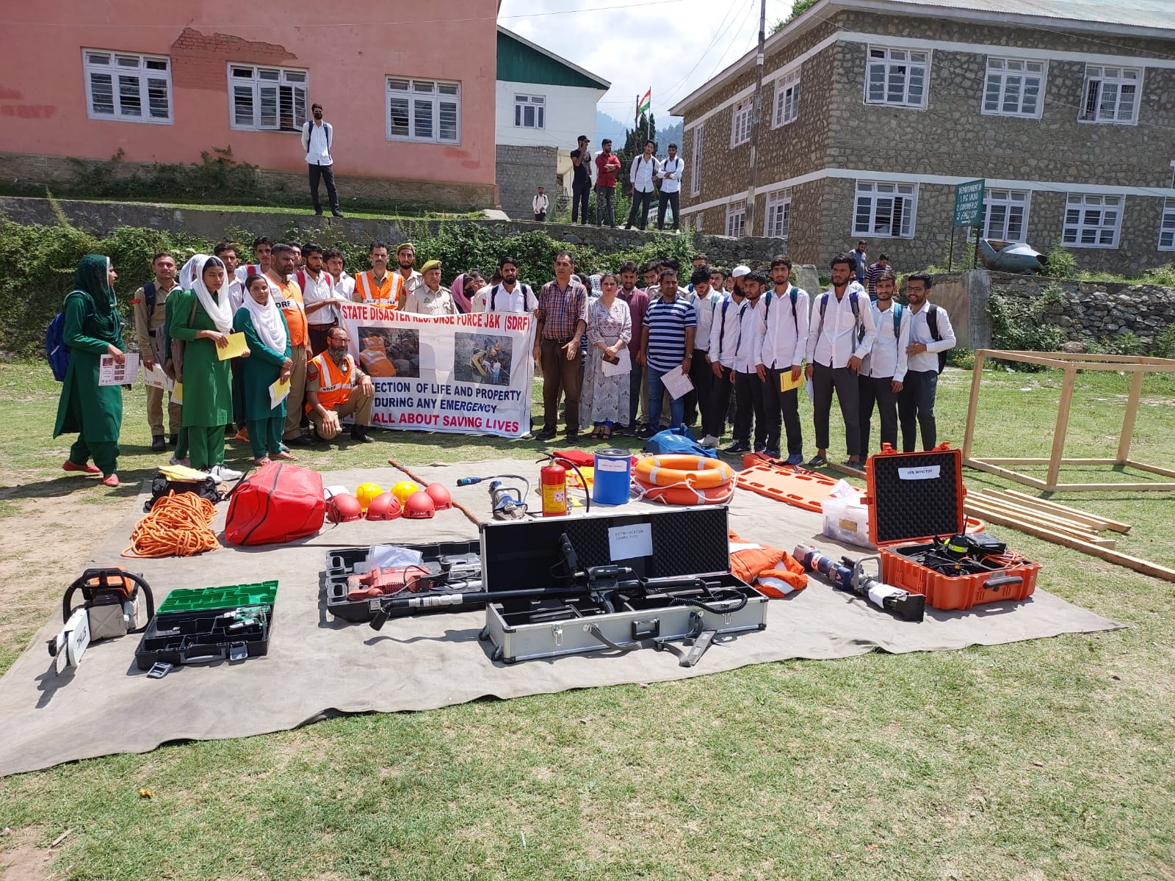

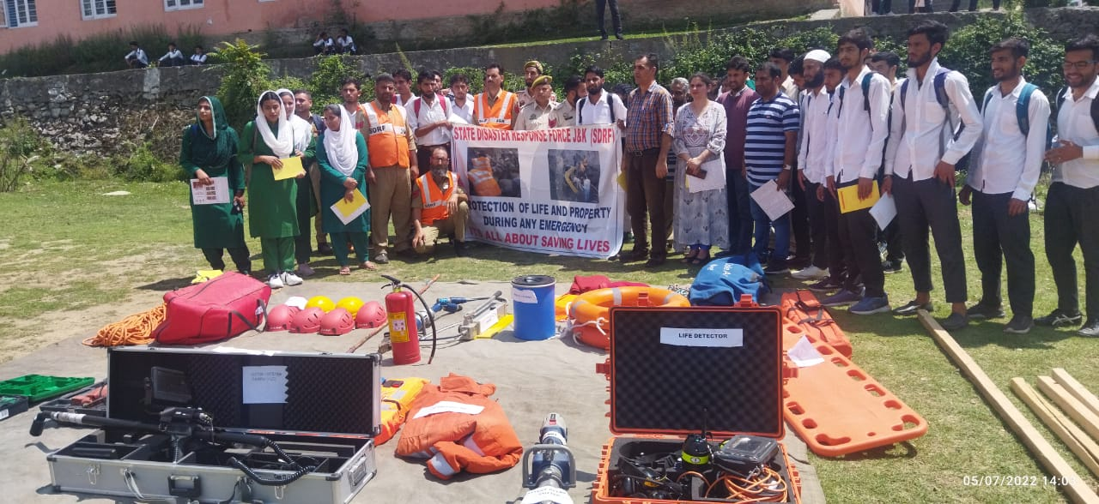

Sd/-
Prof. Anuradha Sharma
Head, Department of Environmental Sciences

