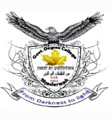 **OFFICE OF THE PRINCIPAL**

**GOVT. DEGREE (PG) COLLEGE BHADERWAH (UT of J&K)**

**(NAAC Accredited ‘B’ Grade Cycle-2)**

**E-mail :** [**principalgdcbhaderwah@gmail.com**](mailto:principalgdcbhaderwah@gmail.com)**, Ph/Fax:01997244155/Mob:+919419910916, website: www.gdcbhadarwah.ac.in**

**\*\*\*\*\***

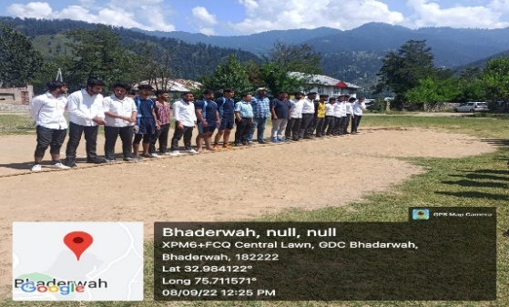**No. : BC/Adm/22/.…. Dated : 14 – 09-2022**

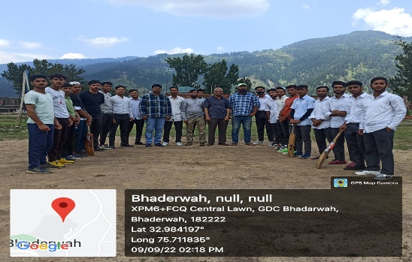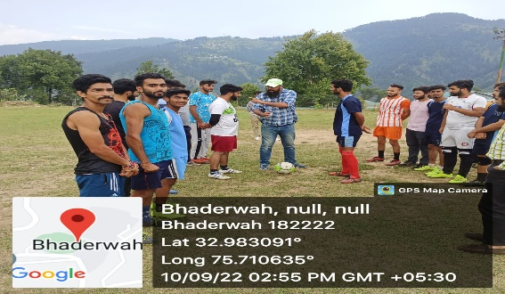

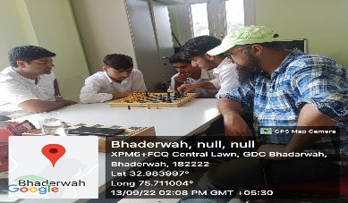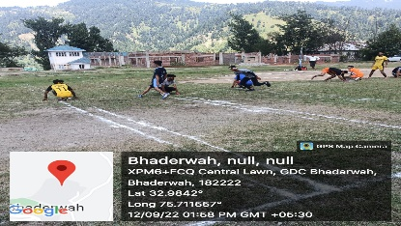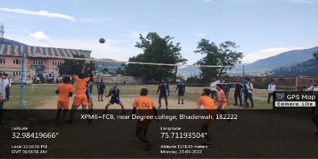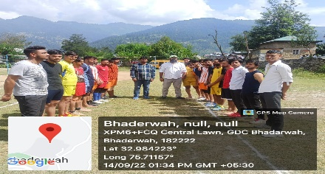p

**Press Release**

A WEEK-LONG MEGA SPORTS COMPETITION UNDER NASHA MUKT BHARAT ABHIYAAN concluded at GDC, Bhaderwah today on 14/09/2022. The event was inaugurated by the principal of the college Dr. Kuldeep Kumar Sharma. The first game in which the students participated was Tug of War which was won by team B led by Talha from semester 2nd. On the 2nd day a cricket match was played between New Star 11 and Sting 11 which was won by Sting 11 by 12 runs Amir from semester 1st took six wickets and was declared man of the match. The college football team won the match 3-1 by defeating Bhaderwah Football Club on the 3rd day of the said event Ayush, Nitin were the goal scorers. On the fourth day a scheduled volleyball match was organised between semester 1st and semester 6th which was won by semester 6th by taking two sets to one by semester 1st. A Kho-Kho match was played between semester 1st and semester 4th in which semester 4th scored a narrow win with the slightest margin of 2 points. Kiran from semester 4th was the top performer of the said match. Continuing with the same enthusiasm a chess competition was held on the 6th day in which four participants namely Asim Pervaiz, Naeem, Imran and Anil Singh competed. Naeem from semester 1st won hands down by defeating all the other three participants in no time. A hard-fought kabaddi match was the final game with which the week-long sports competition culminated under NMBA in which Sumit warriors triumphed over Chenab Hill by margin of 10 points. All these activities were supervised by Mr. Zakir Ali Ganai PTI and convener sports committee Prof. Naz Zargar. The following staff members played an active role to make this week-long sports event successful Prof. Khursheed Ahmed Naqshi, Prof. Manzoor Ahmed, Prof. Renuka Goria, Dr. Naza rul Islam, Dr Irshad, Prof. Ashwani, Prof. Jaideep and Prof. Aijaz Ahmed.

**Principal**

**GDC, Bhaderwah**